**Task 1: Linear Regression Analysis**

Joseph Emmanuel Cayetano

Western Governors University

D600: Statistical Data Mining Task 1

November 5, 2024

1. **Create your subgroup and project in GitLab**

**Gitlab repository URL**: https://gitlab.com/wgu-gitlab-environment/student-repos/jcayet5/d600-statistical-data-mining/-/tree/master?ref_type=heads

**Repository branch history screenshot:** 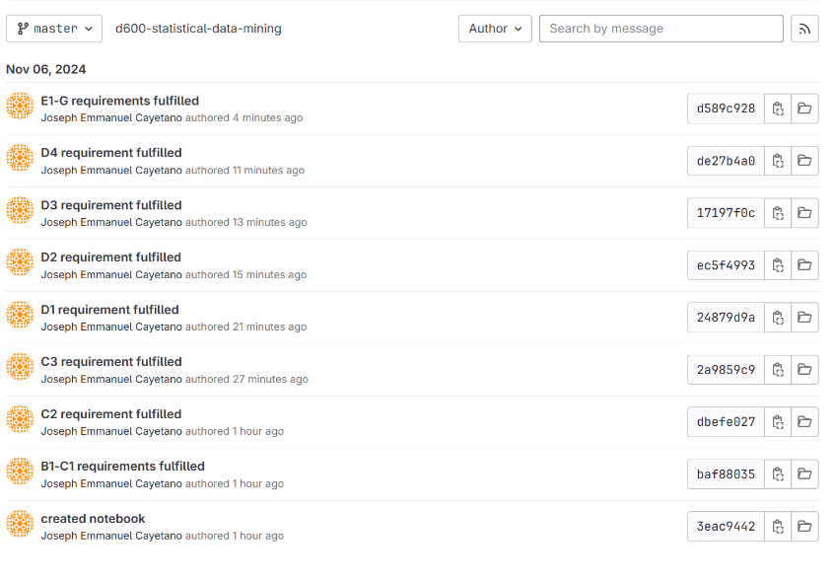

**B1. Propose one research question relevant to a real-world organizational situation that will be answered using multiple linear regression**

The research question that is relevant to the housing dataset and can be answered using multiple linear regression is: What are the key determinants of property prices?

**B2. Define one goal of the data analysis**

One goal of the data analysis is to identify the variables that significantly drive property prices. This goal can help real estate agencies and developers make informed decisions about house pricing strategies. This goal is within the scope of the scenario and data.

**C1. Identify the dependent and all independent variables that are required to answer the research question and justify them**

I have identified the variables to use to answer the research question. Price is the dependent variable because it is the target variable that we aim to predict and understand, and the goal of our data analysis is to identify the variables that significantly influence property prices. The independent variables that I selected are: SquareFootage, NumBathrooms, NumBedrooms, CrimeRate, SchoolRating, AgeOfHome, DistanceToCityCenter, EmploymentRate, PropertyTaxRate, RenovationQuality, LocalAmenities, and TransportAccess. For SquareFootage, large properties typically have higher prices. For NumBathrooms, more bathrooms can increase a property's value. For NumBedrooms, more bedrooms can increase a property's value. For CrimeRate, lower crime rates are typically associated with higher property prices because home buyers prioritize safety. For SchoolRating, having good schools around the area can increase the value of a property. For AgeOfHome, newer homes are typically more expensive than older homes because they were constructed more recently. For DistanceToCityCenter, proximity to urban centers can influence property prices. For EmploymentRate, areas with higher employment rates typically have higher property values. For PropertyTaxRate, higher taxes might affect home buyers' decisions, potentially influencing the price. For RenovationQuality, better renovations typically increase a property's value. For LocalAmenities, the availability of nearby amenities can increase property's price. For TransportAccess, good transport links can increase a property's appeal. I chose these variables as independent variables because they describe physical attributes of a property, the neighborhood, and accessibility. These are the variables that are likely to influence property prices and would be interesting to use with multiple linear regression.

**C2. Describe the dependent variable and all independent variables from part C1 using descriptive statistics and include a screenshot for each.**

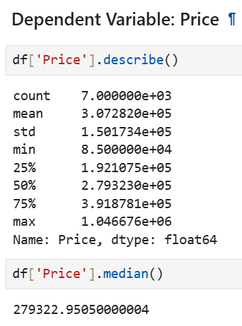

This is the descriptive statistics for the Price variable. It has a total count of 7000, mean value of 307282, median value of 279322, minimum value of 85000, maximum value of 1046676, and a range value of 961676 (max - min).

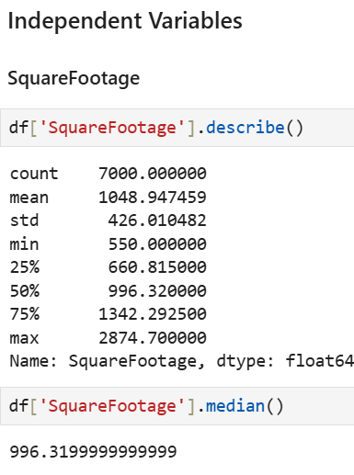

This is the descriptive statistics for the SquareFootage variable. It has a total count of 7000, mean value of 1048.94, median value of 996.31, minimum value of 550, maximum value of 2874, and a range value of 2324 (max - min).

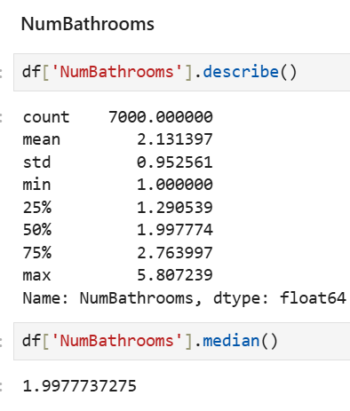

This is the descriptive statistics for the NumBathrooms variable. It has a total count of 7000, mean value of 2.1, median value of 1.99, maximum value of 5.8, minimum value of 1, and a range value of 4.8 (max-min).

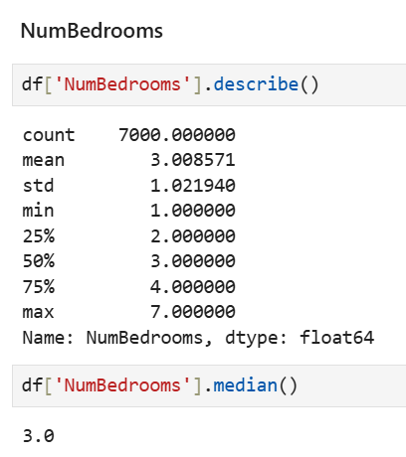

This is the descriptive statistics for the NumBedrooms variable. It has a total count of 7000, mean value of 3, median value of 3, minimum value of 1, maximum value of 7, and a range value of 6 (max-min).

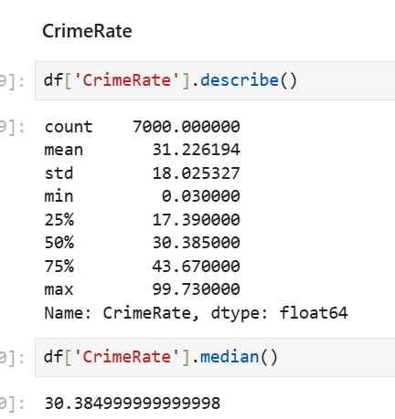

This is the descriptive statistics for the CrimeRate variable. It has a total count of 7000, mean value of 31.2, median value of 30.3, minimum value of 0, maximum value of 99, and a range value of 99 (max-min).

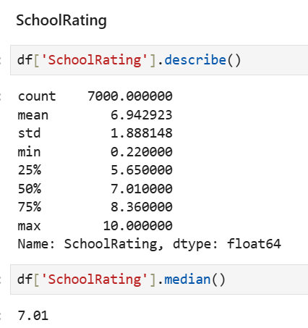

This is the descriptive statistics for the SchoolRating variable. It has a total count of 7000, mean value of 6.9, median value of 7, minimum value of 0, maximum value of 10, and a range value of 10 (max-min).

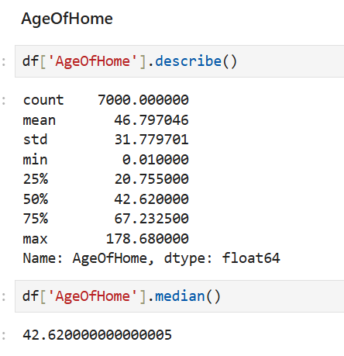

This is the descriptive statistics for the AgeOfHome variable. It has a total count of 7000, mean value of 46.7, median value of 42.6, minimum value of 0, maximum value of 178, and a range of 178 (max-min).

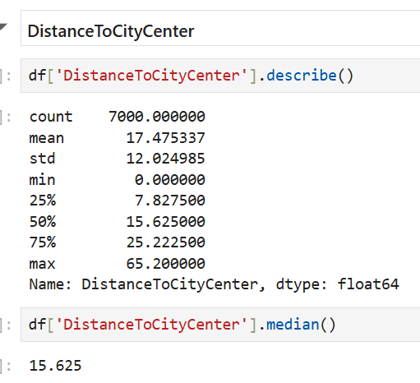

This is the descriptive statistics for the DistanceToCityCenter variable. It has a total count of 7000, mean value of 17.4, median value of 15.6, minimum value of 0, maximum value of 65, and a range value of 65 (max-min).

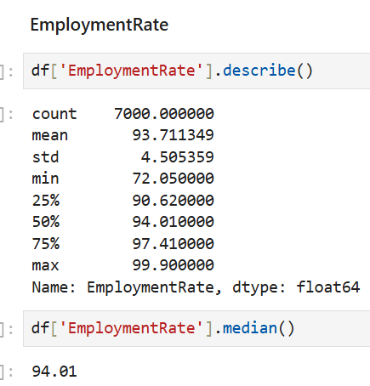

This is the descriptive statistics for the EmploymentRate variable. It has a total count of 7000, mean value of 93.7, median value of 94, minimum value of 72, maximum value of 99, and a range value of 27 (max-min).

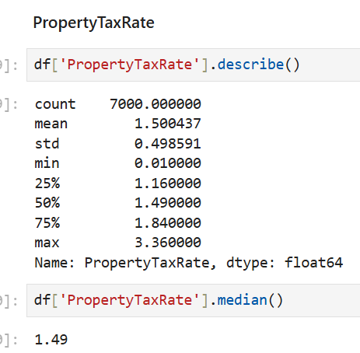

This is the descriptive statistics for the PropertyTaxRate variable. It has a total count of 7000, mean value of 1.5, median value of 1.4, minimum value of 0, maximum value of 3.3, and a range value of 3.3 (max-min).

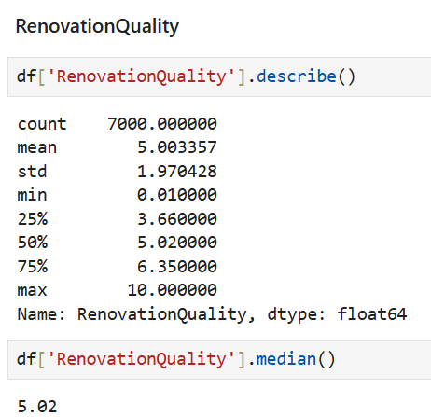

This is the descriptive statistics for the RenovationQuality variable. It has a total count of 7000, mean value of 5, median value of 5, minimum value of 0, maximum value of 10, and a range value of 10 (max-min).

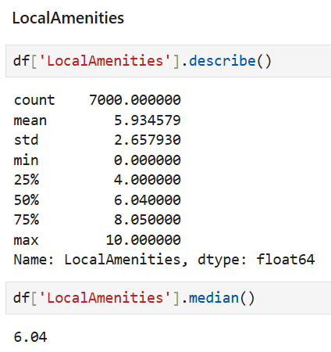

This is the descriptive statistics for the LocalAmenities variable. It has a total count of 7000, mean value of 5.9, median value of 6, minimum value of 0, maximum value of 10, and a range of value of 10 (max-min).

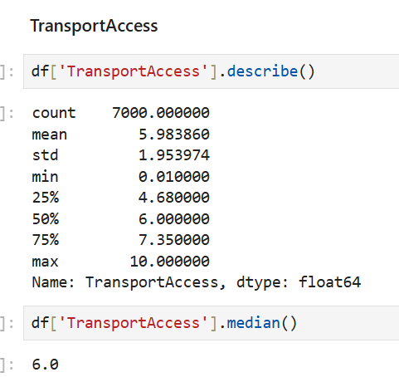

This is the descriptive statistics for the TransportAccess variable. It has a total count of 7000, mean value of 5.9, median value of 6, minimum value of 0, maximum value of 10, and a range value of 10 (max-min).

**C3. Generate univariate and bivariate visualizations of the dependent and independent variables, including the dependent variable in the bivariate visualizations.**

Univariate Visualizations

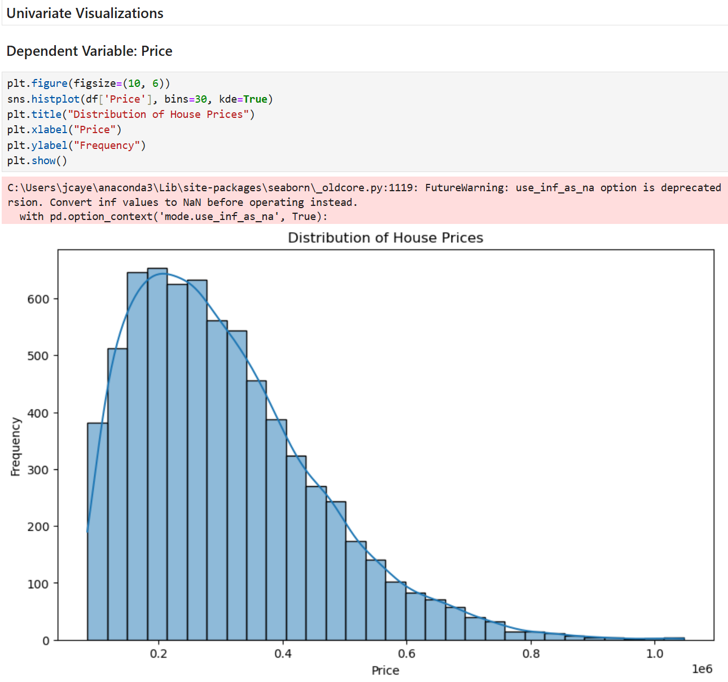

Looking at the histogram for the Price variable, it is right-skewed. Most houses in the data are in the 100,000 to 300,000 price range, while there are fewer houses that are significantly higher priced.

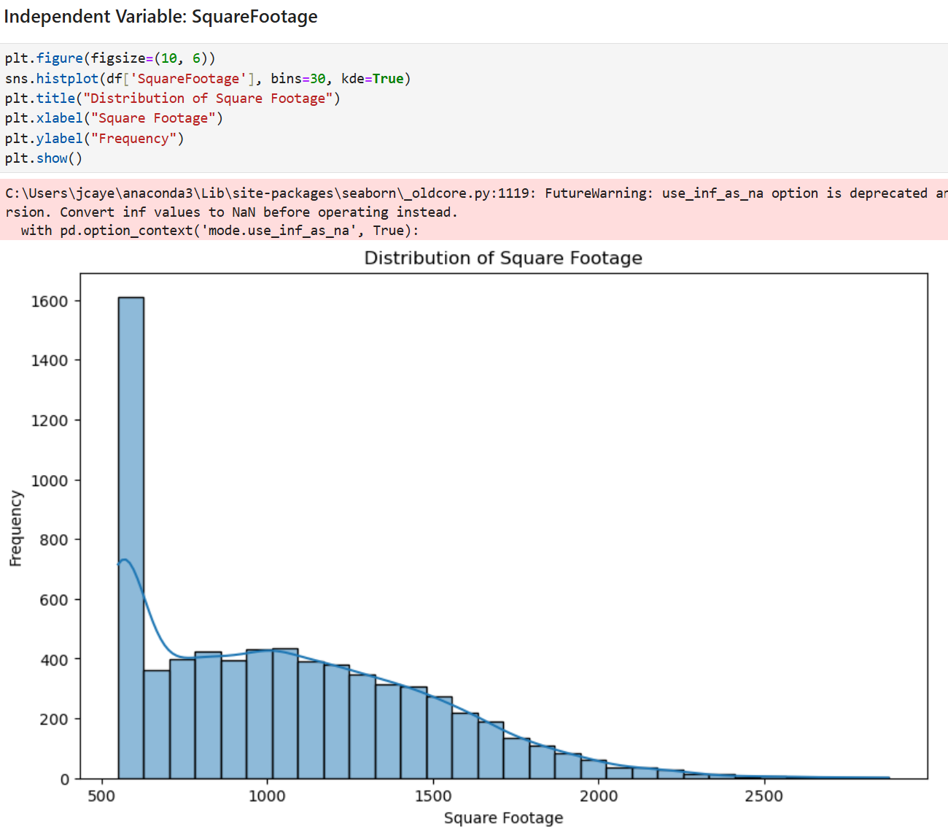

Looking at the histogram for the SquareFootage variable, it is right-skewed. Most houses in the data only have a square footage of around 500, which can be seen by the tall bar on the left. There are fewer houses that have significantly larger square footage.

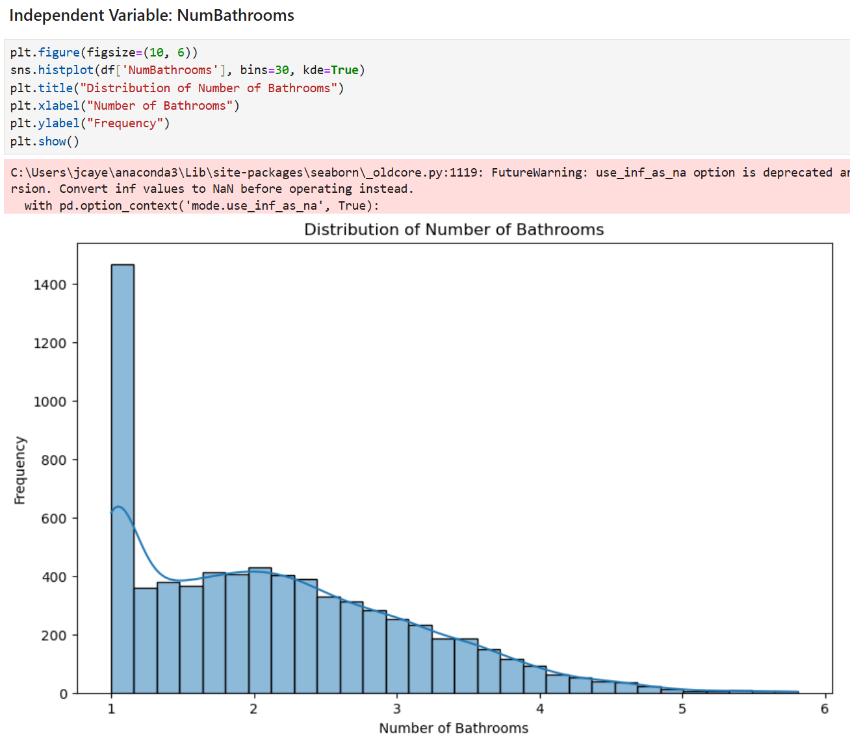

Looking at the histogram for the NumBathrooms variable, it is right-skewed. Most houses in the data only have 1-2 bathrooms, while there are fewer houses with 3 or more bathrooms.

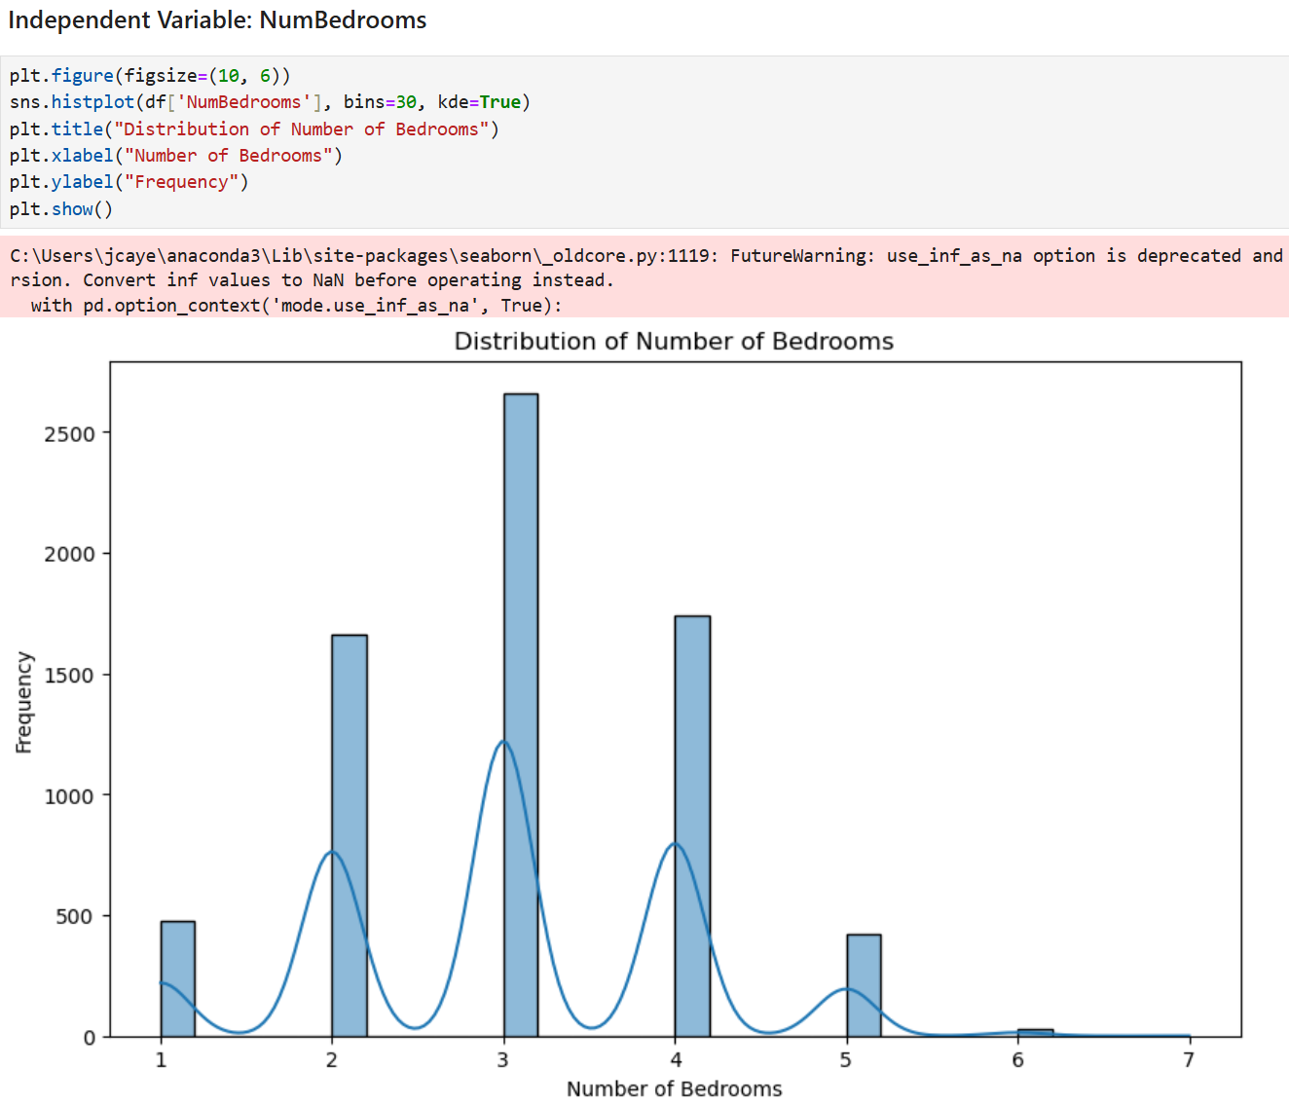

Looking at the histogram for the NumBedrooms variable, it is multi-modal where it has more than one peak. Most houses in the data have 2 to 4 bedrooms, with 3-bedroom houses being the most common. There are fewer houses with more than 4 bedrooms.

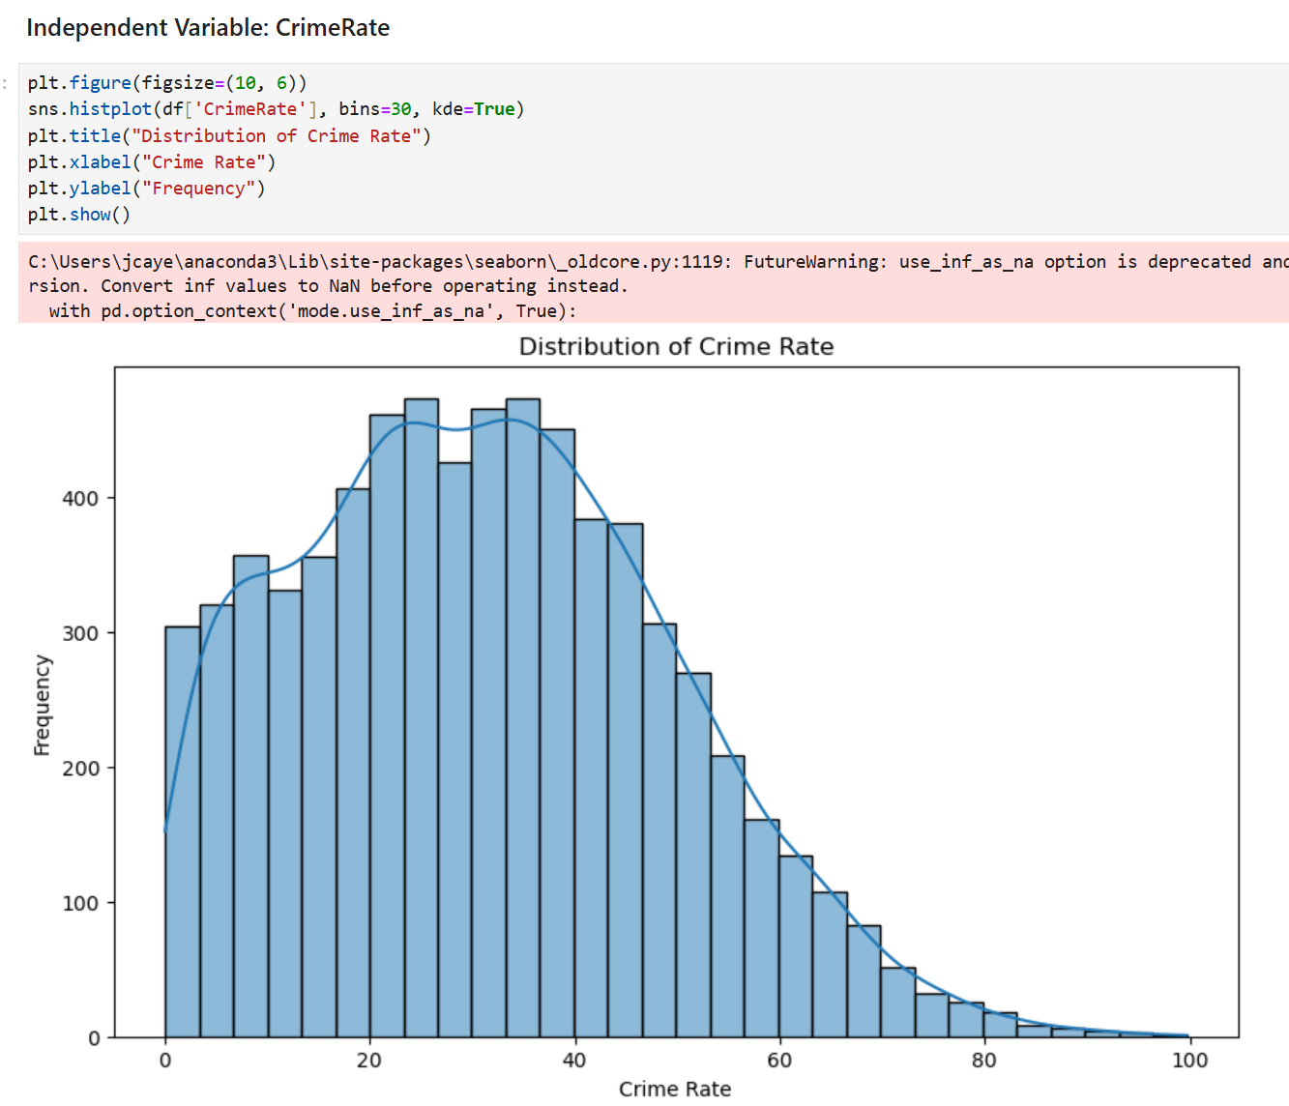

Looking at the histogram for the CrimeRate variable, it is slightly right skewed. Most areas in the data have a crime rate in the range of 20 to 50, while there are fewer areas that have a crime rate above 50. This distribution indicates that most areas in the data have moderate crime rates.

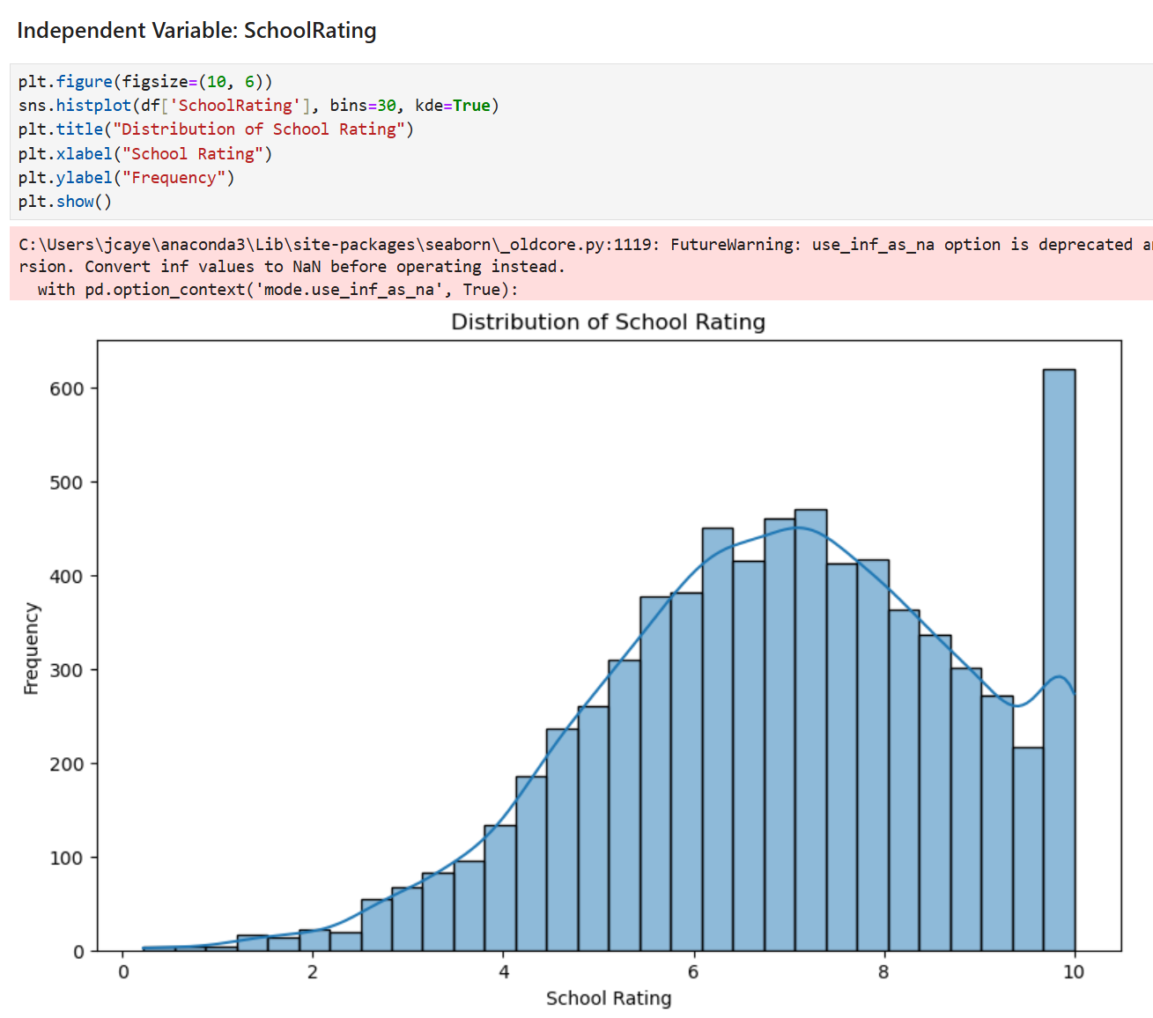

Looking at the histogram for the SchoolRating variable, it is left-skewed. Most houses in the data have good school systems, while there are only few with poor-quality education.

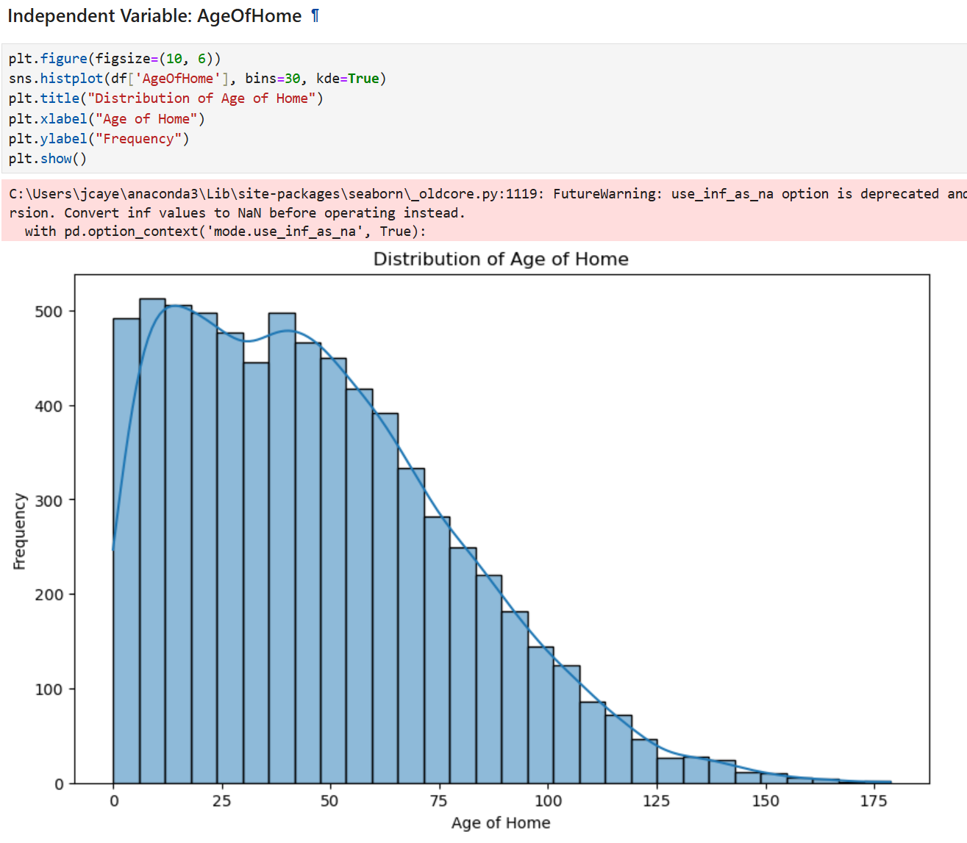

Looking at the histogram for the AgeOfHome variable, it is right-skewed. Most houses in the data are relatively new and fall within the range of 0 to 50 years. Houses that are over 100 years old are rare.

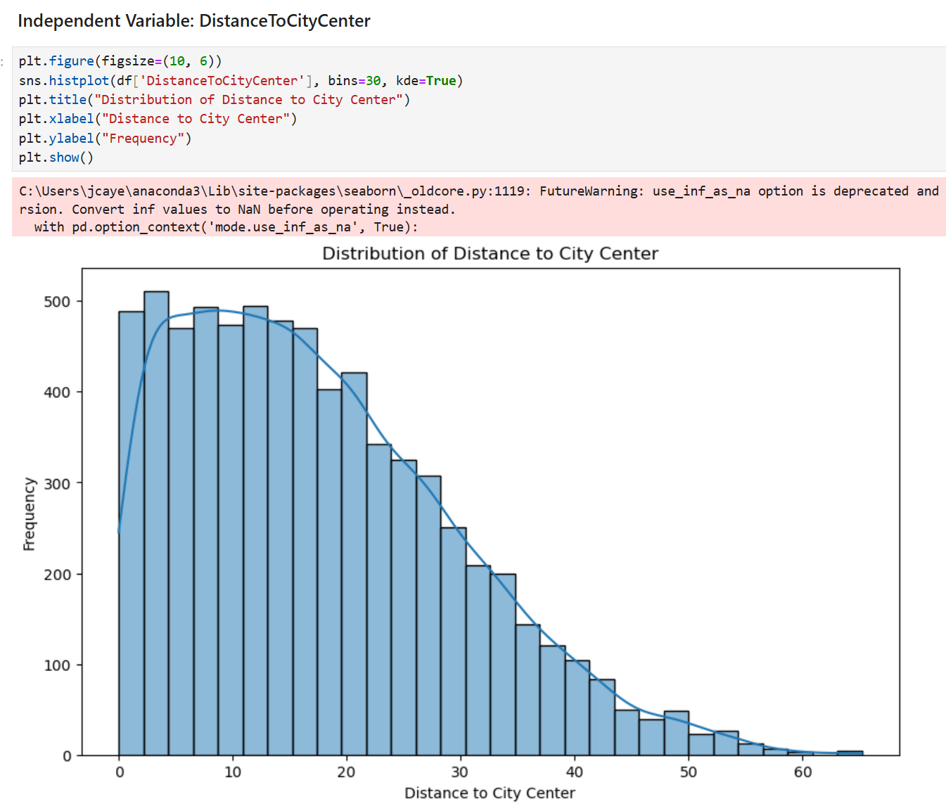

Looking at the histogram for the DistanceToCityCenter variable, it is right-skewed. Most houses in the data have a distance to the city center within the range of 0 to 20 miles, while there are fewer houses that are located farther away from the city center.

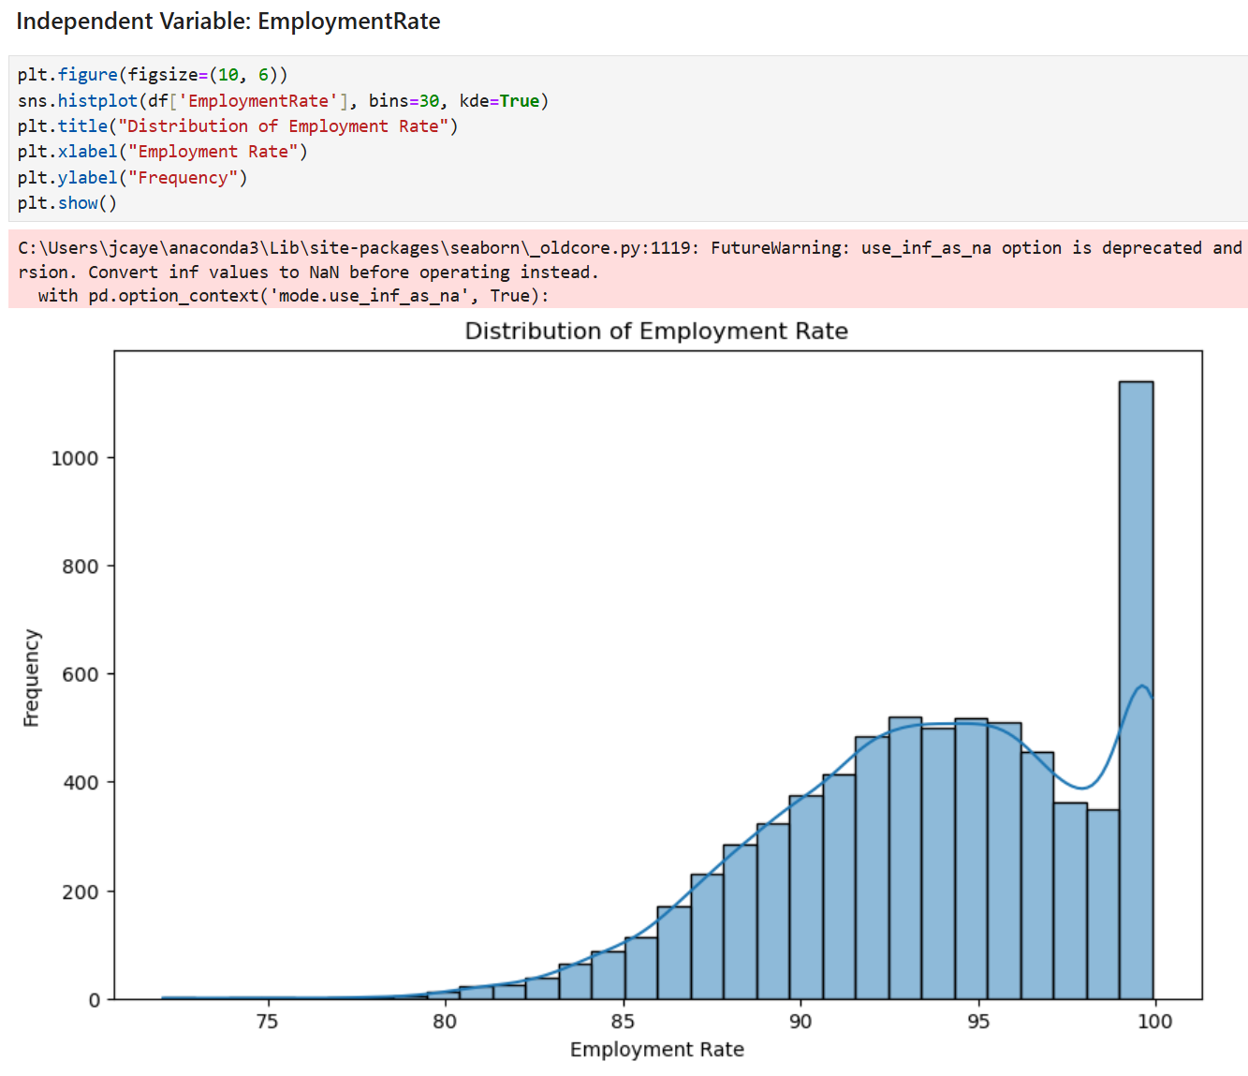

Looking at the histogram for the EmploymentRate variable, it is left skewed. Most areas in the data have high employments rate and are within the range 90 to 100. Areas that have an employment rate of less than 85 are uncommon.

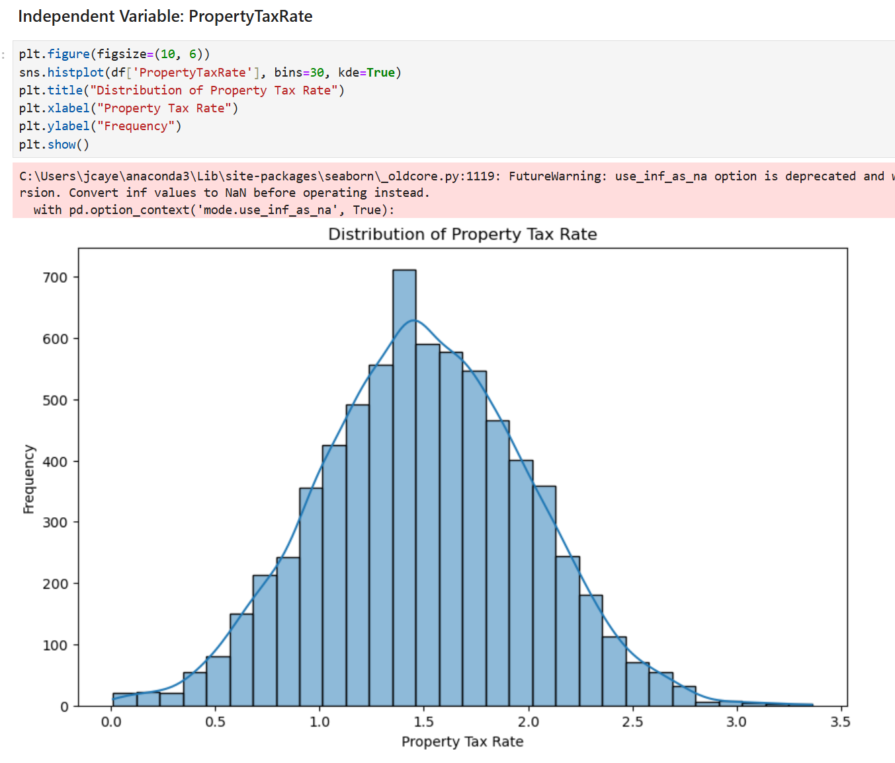

Looking at the histogram for the PropertyTaxRate variable, it is normally distributed. Most houses in the data have property tax rates within the range 1.0 to 2.0, while there are fewer houses with property tax rates below 1.0 and above 2.0.

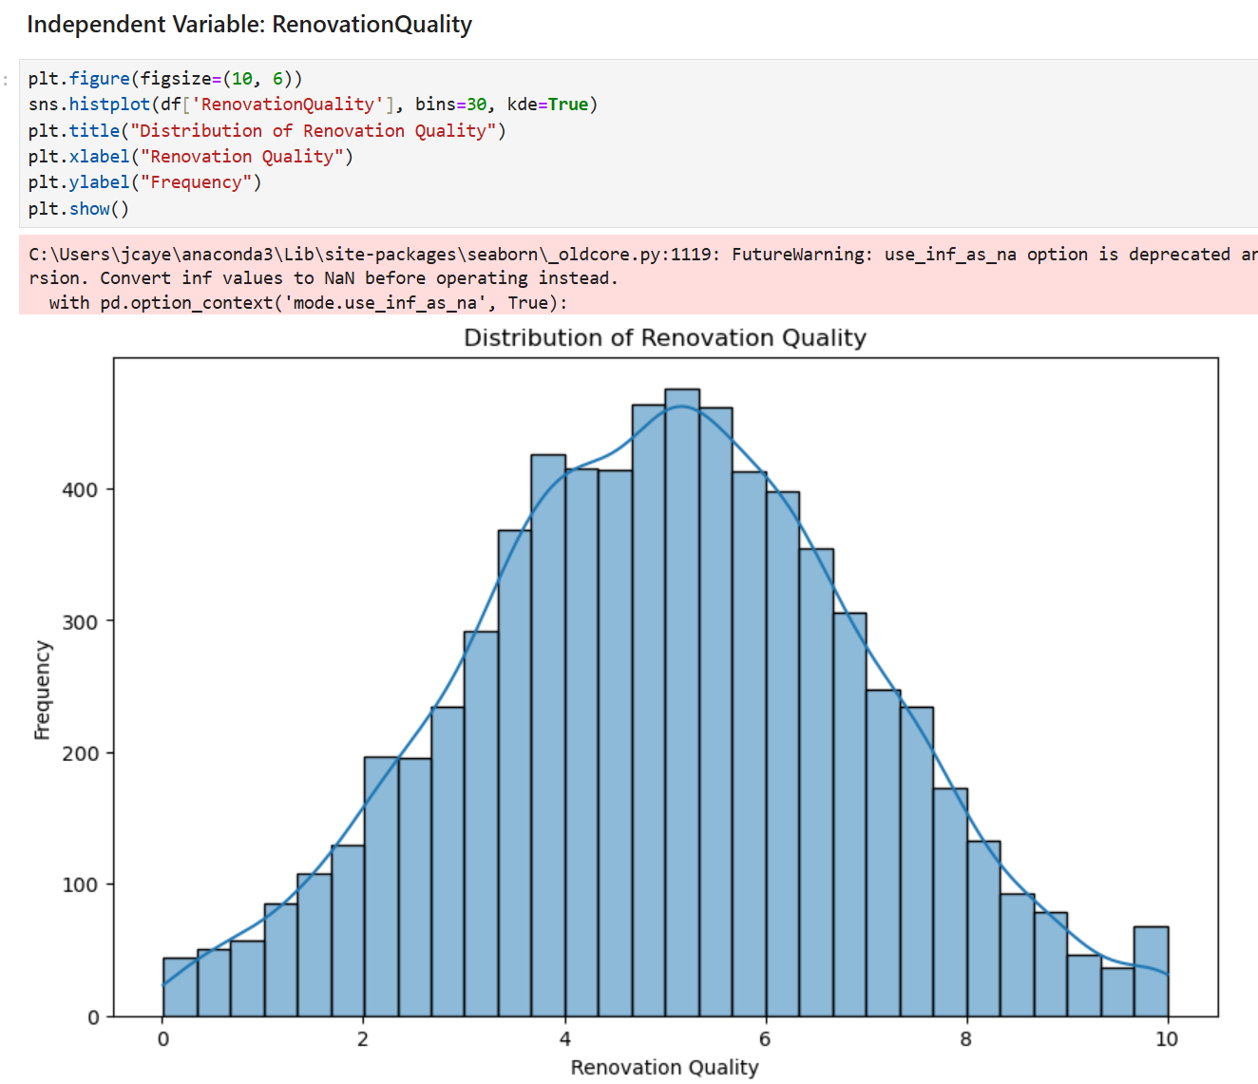

Looking at the histogram for the RenovationQuality variable, it is normally distributed. Most houses in the data have a renovation quality within the range 3 to 7, while there are few houses with a renovation quality below 3 and above 7.

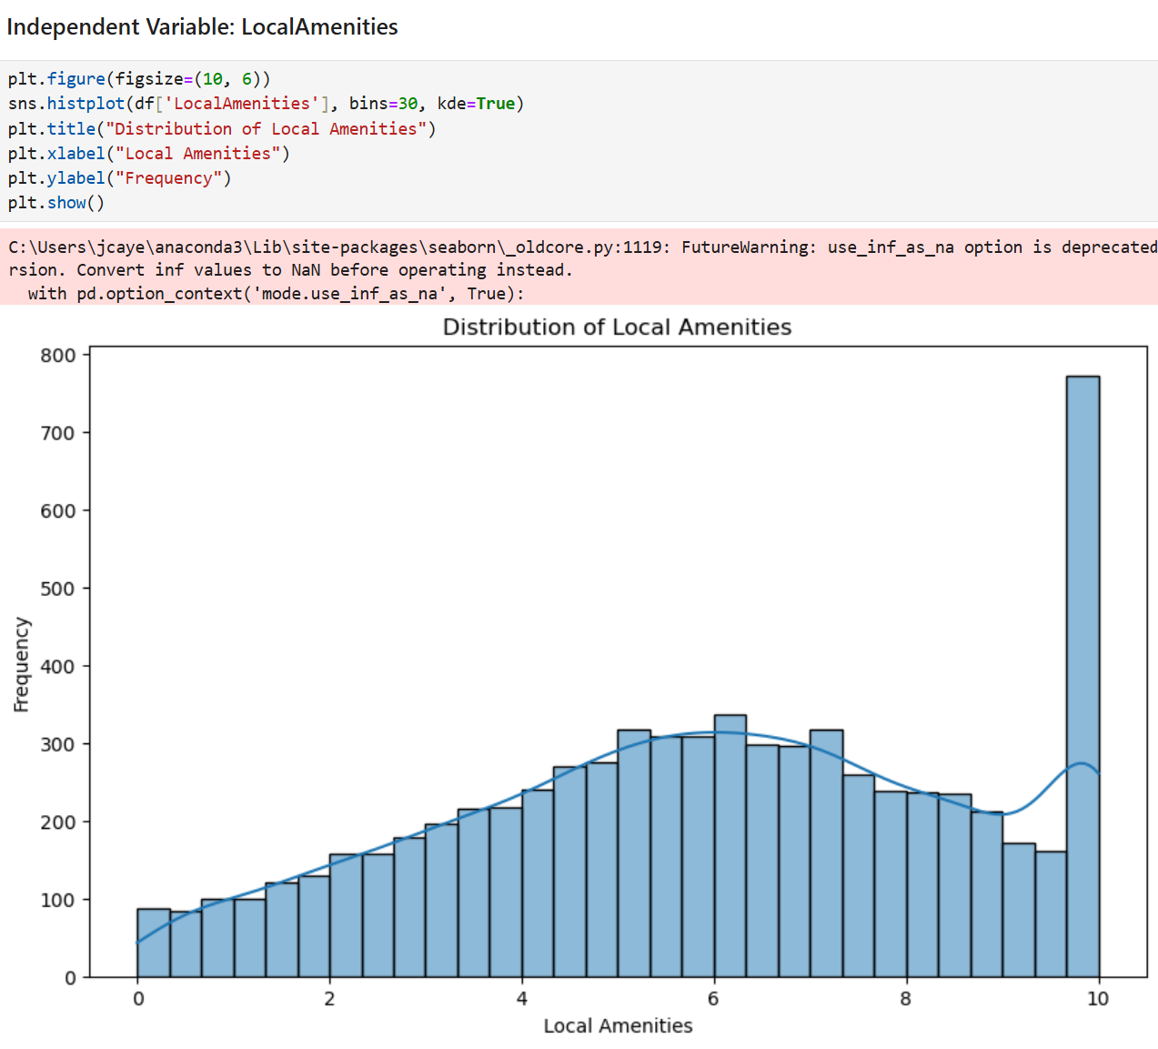

Looking at the histogram for the LocalAmenities variable, it has a peak at 10. This indicates that there is a large number of houses in the data with local amenities value of 10. Other than that, the distribution of local amenities is relatively even from 0 to 9.

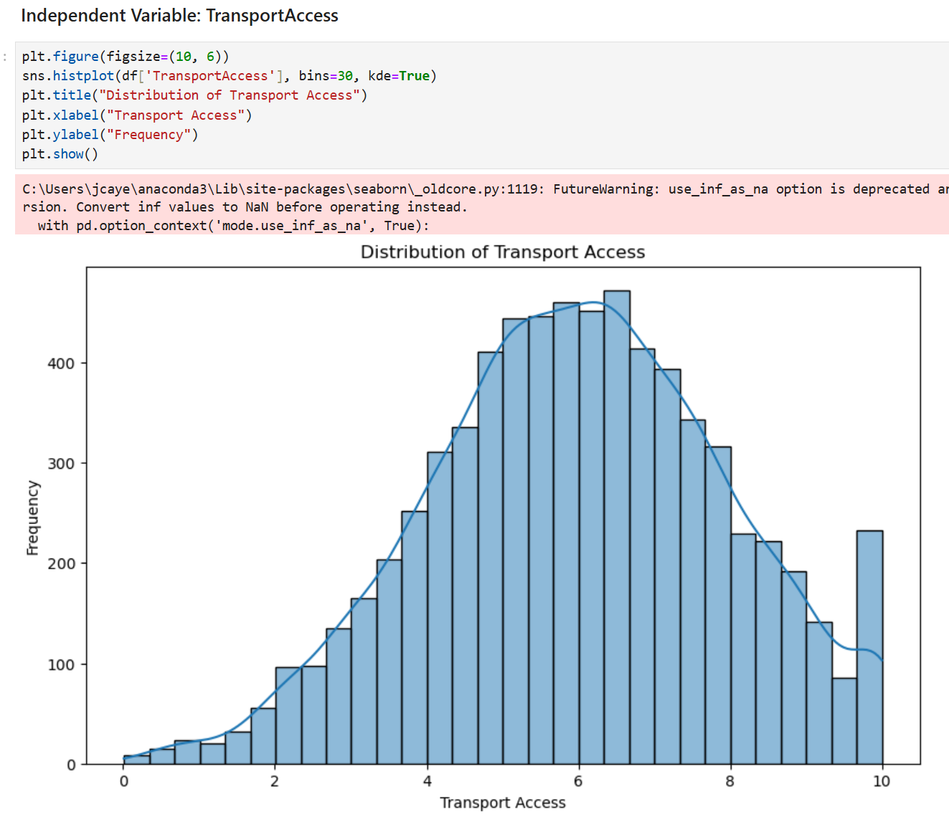

Looking at the histogram for the Transport Access variable, it is normally distributed. Most houses in the data have a transport access value within the range 4 to 8, while there are fewer houses that have very low or very high transport access.

Bivariate Visualizations

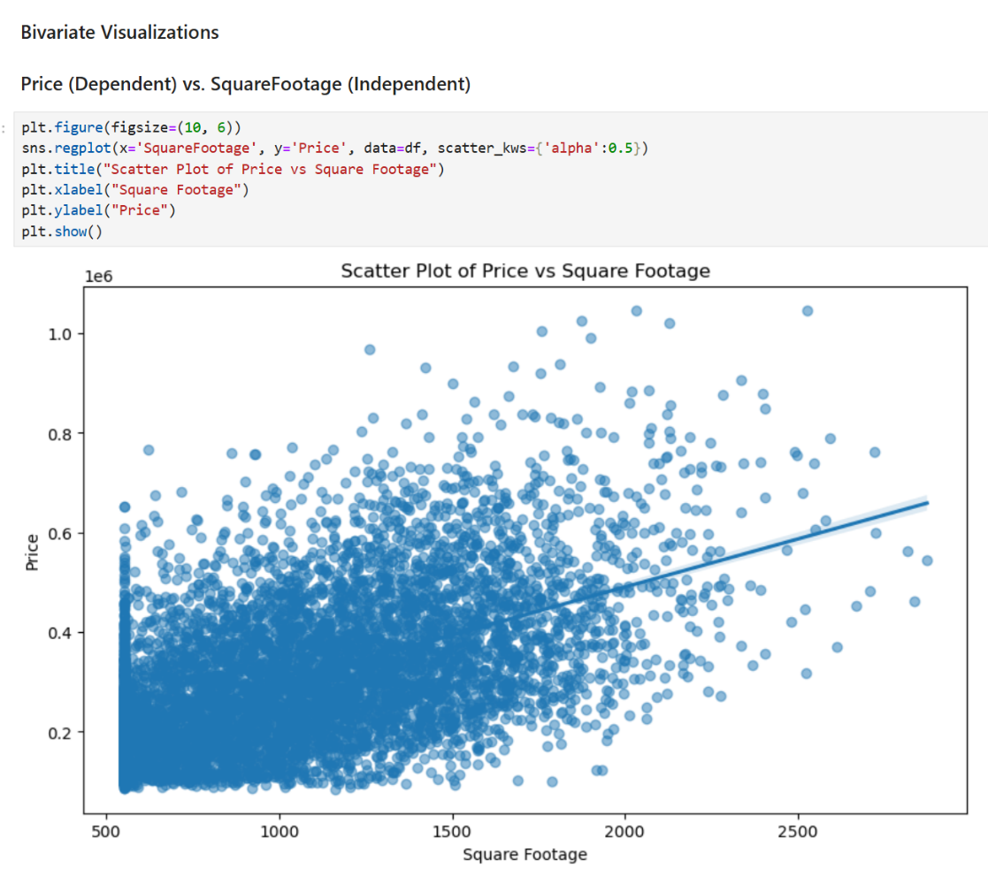

Looking at the scatterplot for Price vs. SquareFootage, there is a positive correlation between the two variables. The scatterplot indicates that as square footage increases, the price of the house typically increases as well.

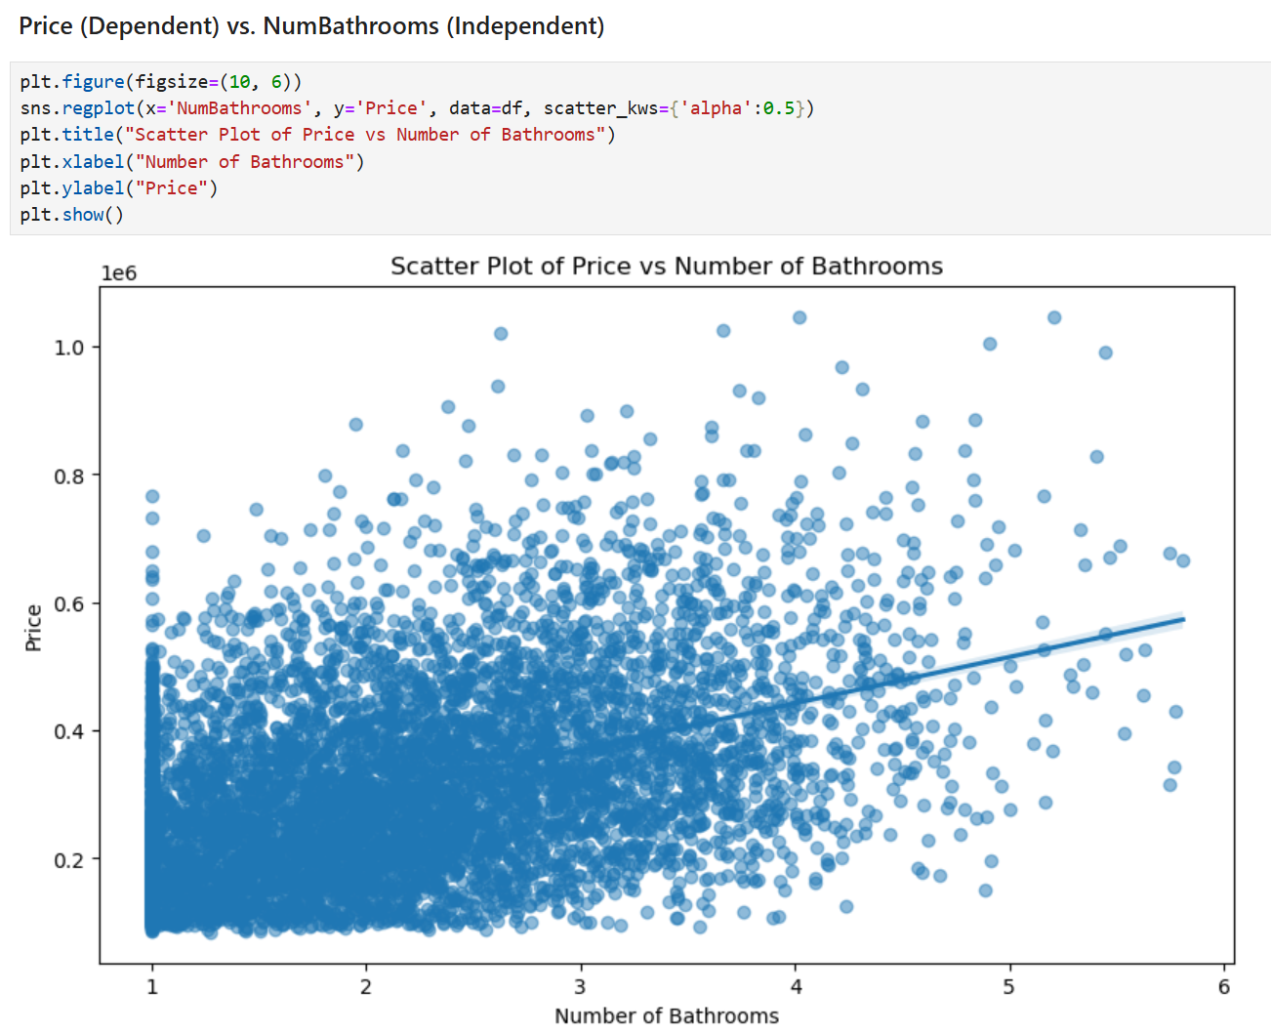

Looking at the scatterplot for Price vs. NumBathrooms, there is a positive correlation between the two variables. The scatterplot indicates that as the number of bathrooms increases, the price of the house typically increases as well.

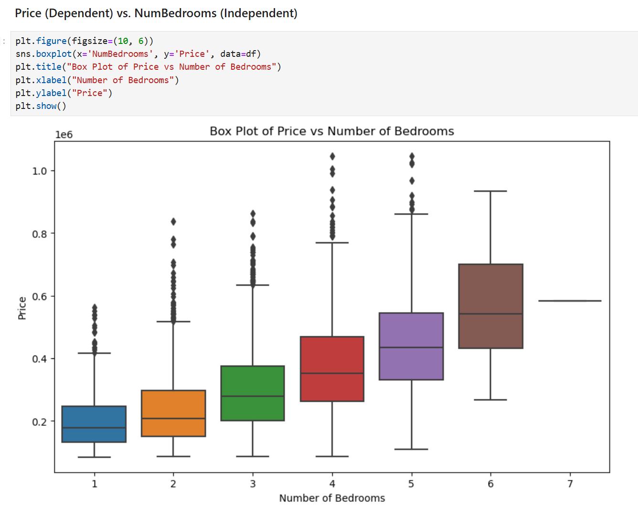

Looking at the boxplot for Price and NumBedrooms, it shows that as the number of bedrooms increases, the median price typically increases as well. This is consistent with the expectation that houses with more bedrooms are generally more expensive.

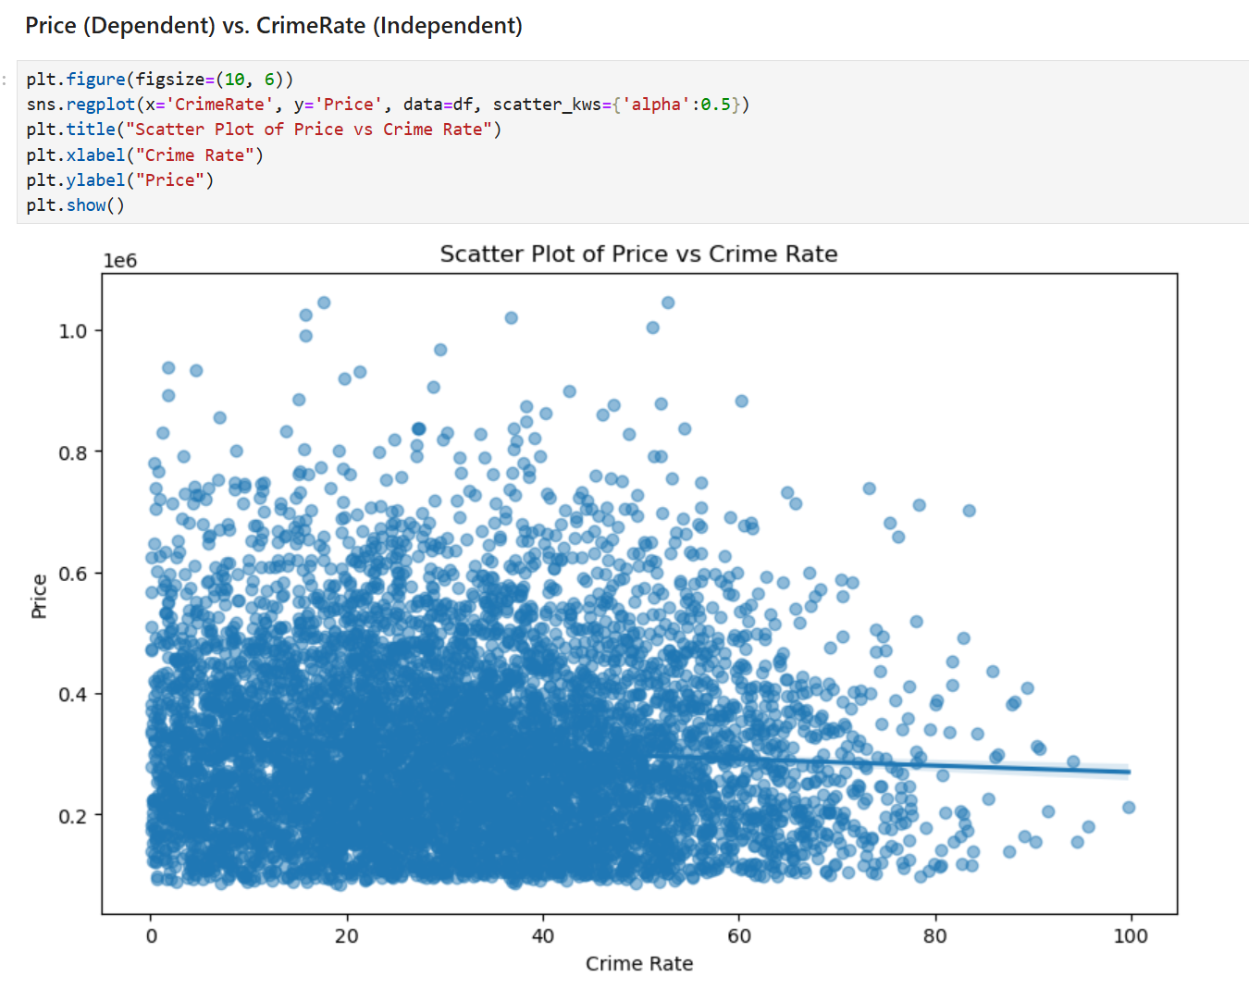

Looking at the scatterplot for Price vs. Crime Rate, there is a negative correlation between the two variables, though it is a weak correlation. The scatterplot indicates that houses in areas with higher crime rates typically have slightly lower prices.

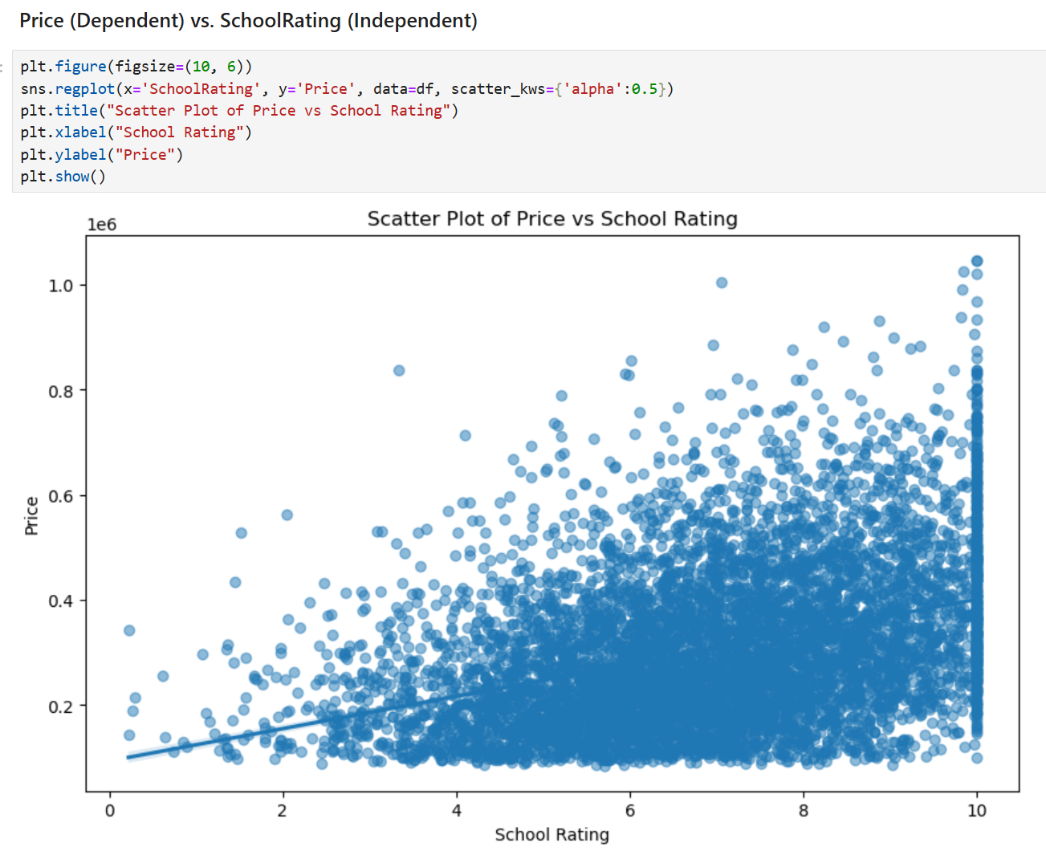

Looking at the scatterplot for Price vs. SchoolRating, there is a positive correlation between the two variables. The scatterplot indicates that houses in areas with a good school system typically have higher prices.

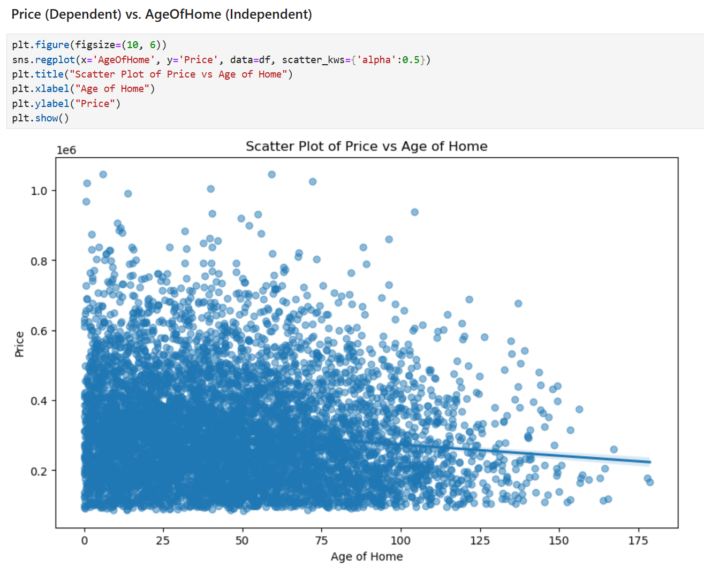

Looking at the scatterplot for Price vs. AgeOfHome, there is a negative correlation between the two variables, though it is a weak correlation. The scatterplot indicates that older homes typically have slightly lower prices.

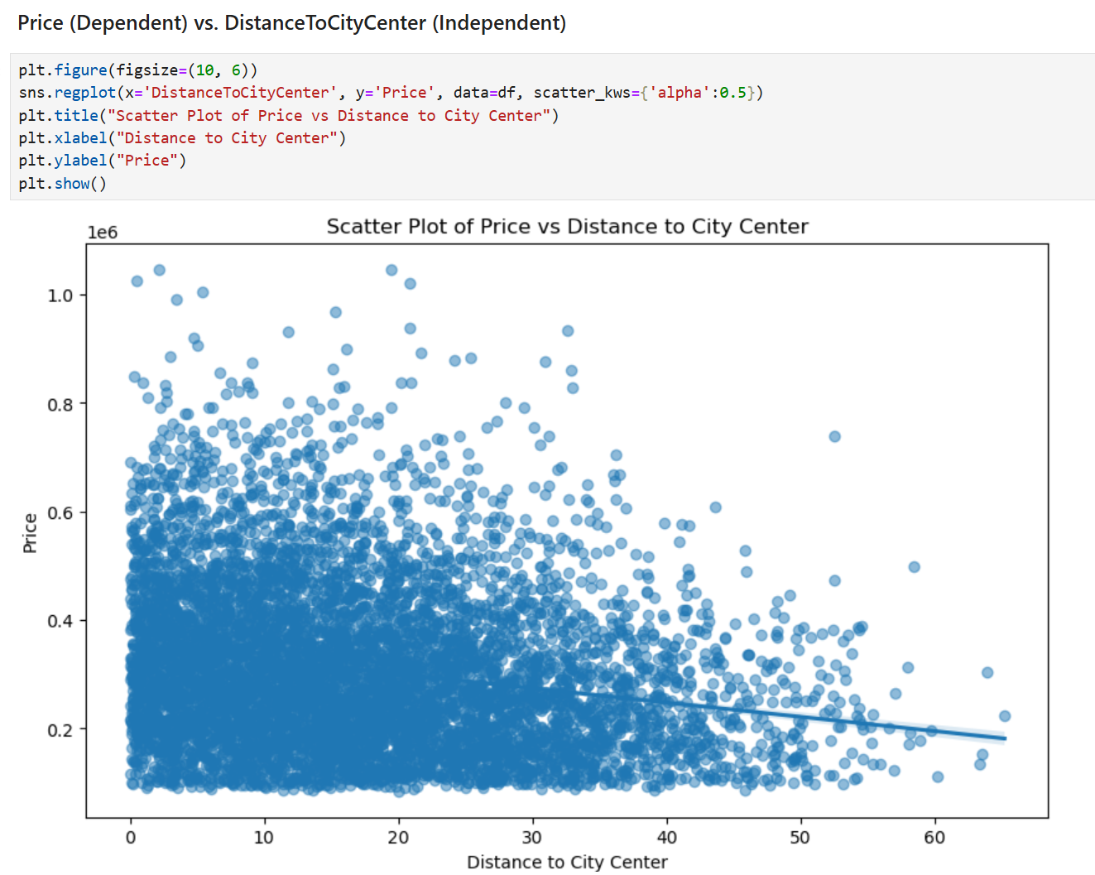

Looking at the scatterplot for Price vs. DistanceToCityCenter, there is a negative correlation between the two variables, though it is a weak correlation. The scatterplot indicates that homes that are located farther away from the city center typically have slightly lower prices.

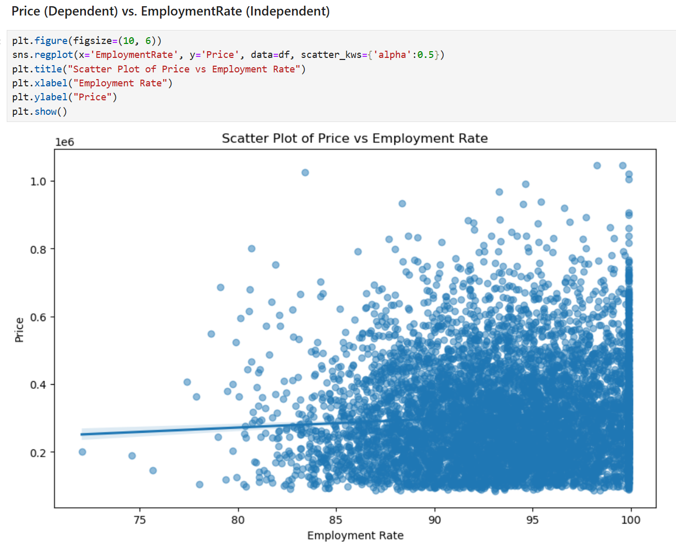

Looking at the scatterplot for Price vs. EmploymentRate, there is a positive correlation between the two variables, though the correlation is weak. The scatterplot indicates that houses in areas that have higher employment rates typically have slightly higher prices.

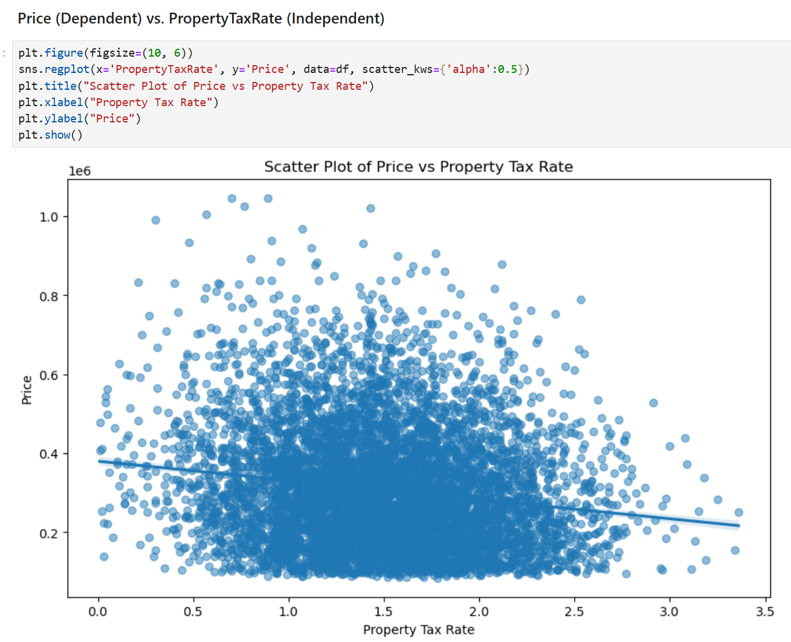

Looking at the scatterplot for Price vs. PropertyTaxRate, there is a negative correlation between the two variables, though the correlation is weak. The scatterplot indicates that houses in areas with higher property tax rates typically have slightly lower prices.

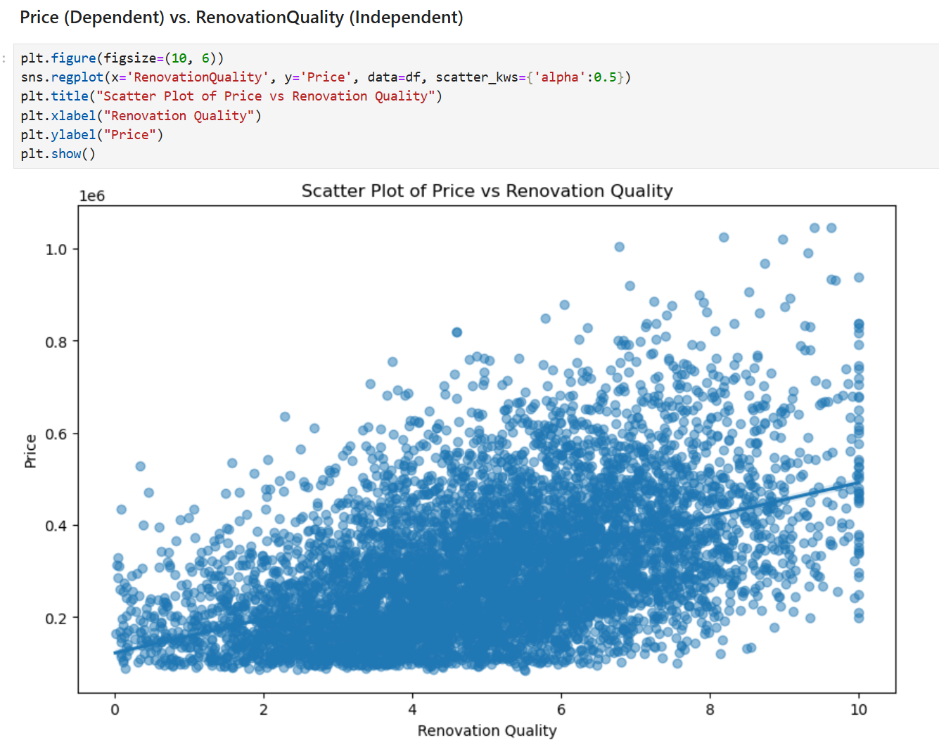

Looking at the scatterplot for Price vs. RenovationQuality, there is a positive correlation between the two variables. The scatterplot indicates that houses with higher renovation quality tend to have higher prices.

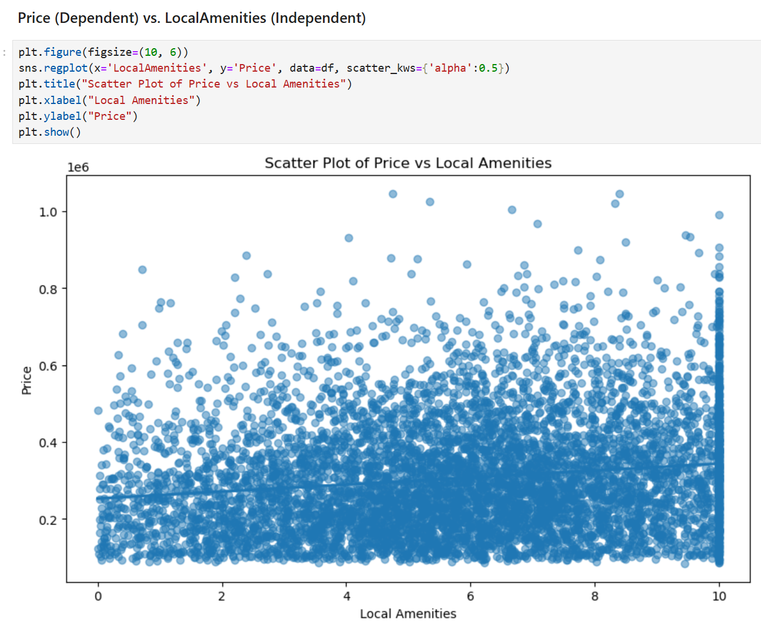

Looking at the scatterplot for Price vs. LocalAmenities, there is a positive correlation between the two variables, though the correlation is weak. The scatterplot indicates that houses in areas with many amenities typically have slightly higher prices.

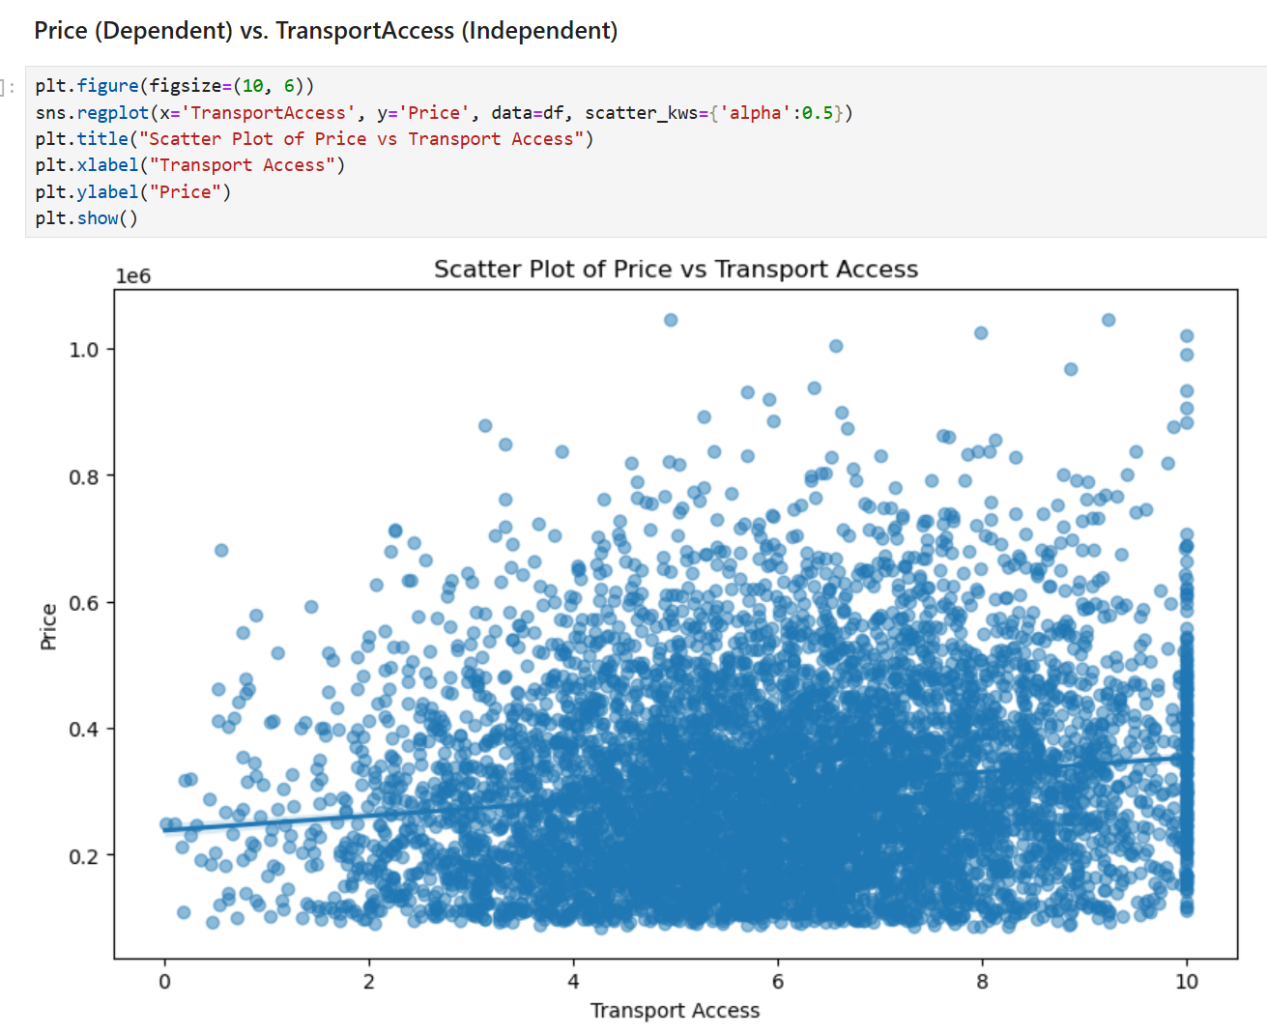

Looking at the scatterplot for Price vs. TransportAccess, there is a positive correlation between the two variables, though the correlation is weak. The scatterplot indicates that houses with better access to transportation might have slightly higher prices.

**D1. Split the data into two datasets, with a larger percentage assigned to the training dataset and a smaller percentage assigned to the test data set. Provide the files**

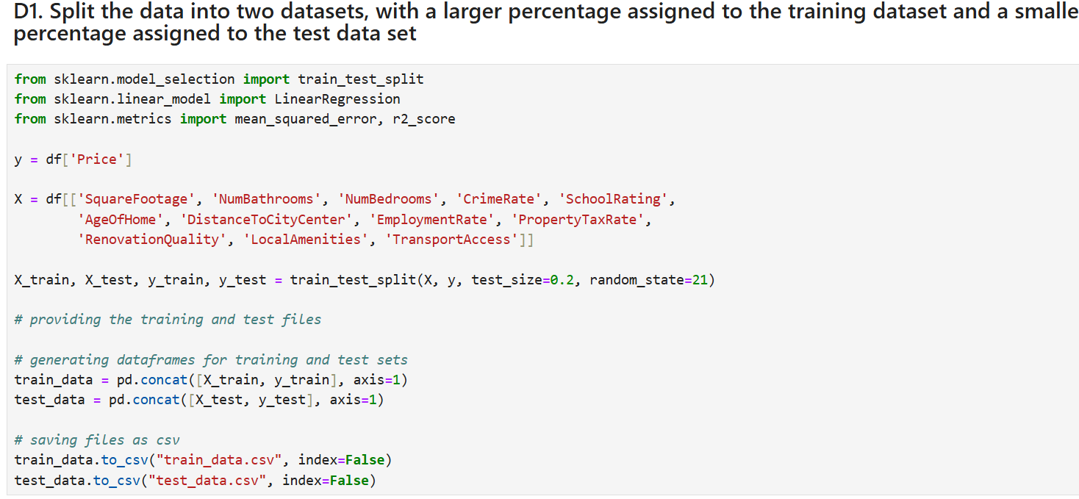

In this code, I've imported the train_test_split function from sklearn.model_selection because the function allows me to split the data into training and testing datasets. The y variable contains the dependent variable Price, and the X variable contains the 12 independent variables. I split the data and 20% of the data goes to the testing set, while 80% of the data goes to the training set. I also used the parameter random_state to ensure reproducibility. The X_train and y_train variables will contain the training data, while the X_test and y_test variables will contain the testing data. I have concatenated both X_train and y_train and stored them into train_data variable, and concatenated both X_test and y_test and stored them into the test_data variable. I have saved both train_data and test_data as csv files and exported them for submission. The files are named “train_data.csv” and “test_data.csv”.

**D2. Perform a regression model using the training set. Optimize the regression model and provide a screenshot of the summary of the model or the key parameters**

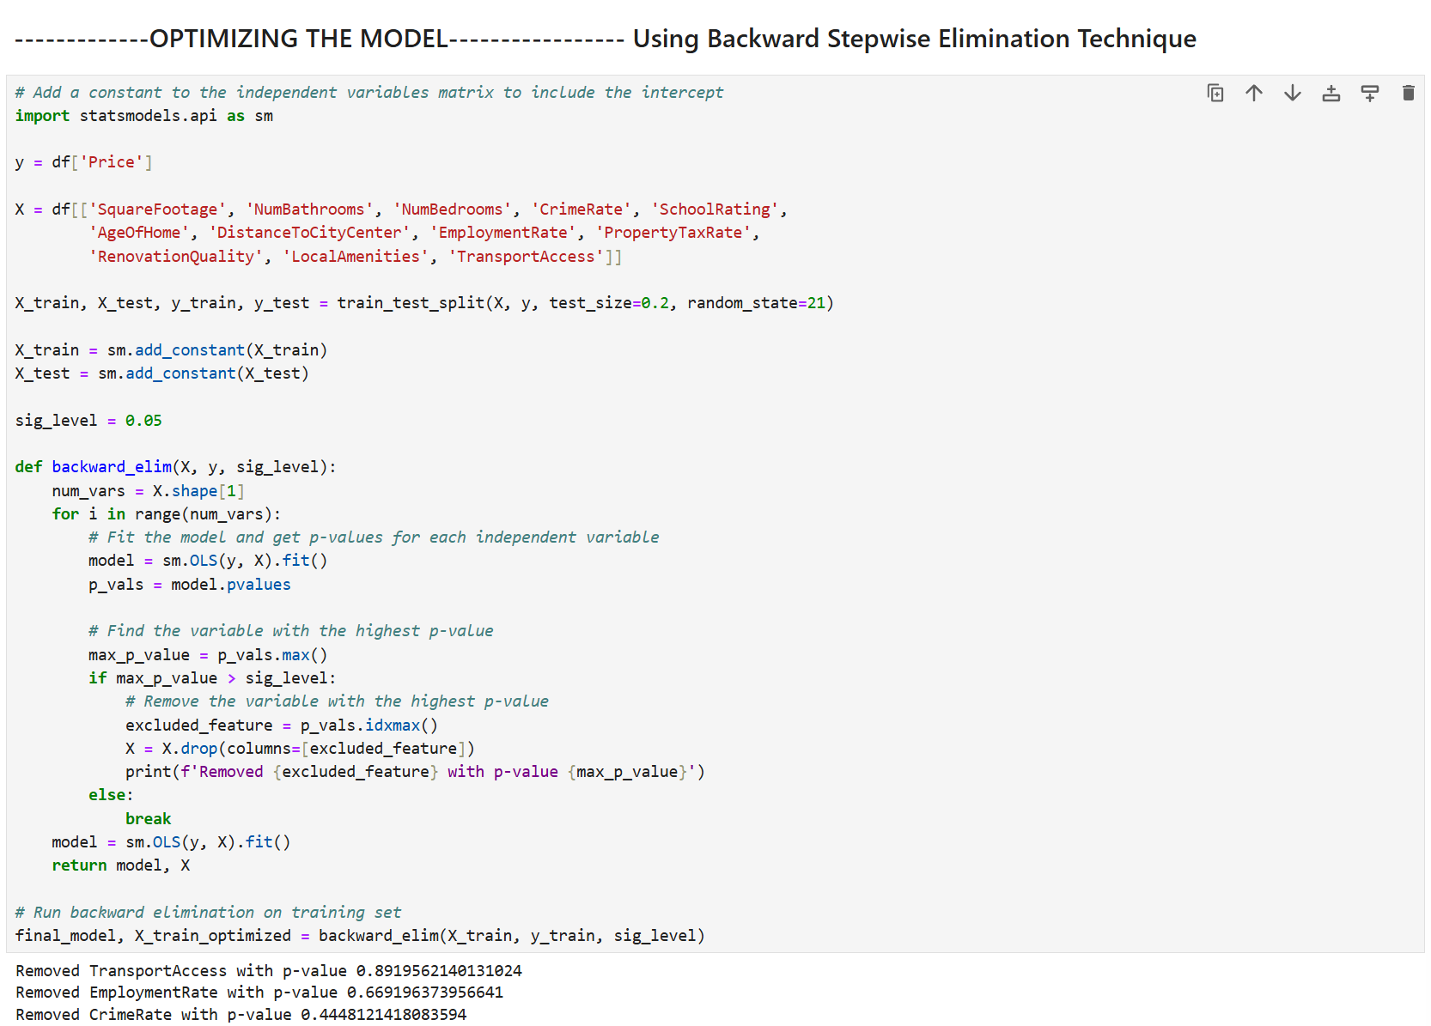

In this code, we are using the backward stepwise elimination technique to optimize the multiple linear regression model from earlier. The goal of this technique is to remove the least significant predictors and retain the significant ones by removing the independent variables with p-values above 0.05 and retaining only the significant variables with p-values below 0.05 in the model.

The y variable contains the dependent variable Price, and the X variable contains the 12 independent variables. I used the train_test_split() function to split the data into training and testing datasets, with 20% of the data goes to the testing set and 80% of the data goes to the training set. Then, I used the add_constant() function from statsmodels to add a constant to both training and testing sets. I assigned a value of 0.05 to the variable sig_level, as this variable represents the p-value threshold. Any independent variable that has a p-value above this threshold will be removed from the model.

I created a function called backward_elim and this function will perform the backward elimination method. Inside this function, there will be a loop that iterates over each independent variable. The Ordinary Least Squares (OLS) function will be used to optimize the multiple linear regression model from earlier because the goal of OLS is to adjust the parameter of the model by minimizing the sum of squared residuals. The OLS() function will fit an ordinary least squares regression model, and the pvalues() function retrieves the p-values for each independent variable. If there is a variable with a p-value greater than sig_level (0.05), it will be removed from the model. Otherwise, it gets retained. After the loop finishes, it fits and returns the final regression model and the remaining significant predictors or variables.

The final_model is the final optimized regression model that was created inside the backward_elim function, and X_train_optimized are the variables or predictors that met the significance threshold.

The variables that were removed are EmploymentRate, CrimeRate and TransportAccess. These variables had p-values that were greater than the 0.05 significance level.

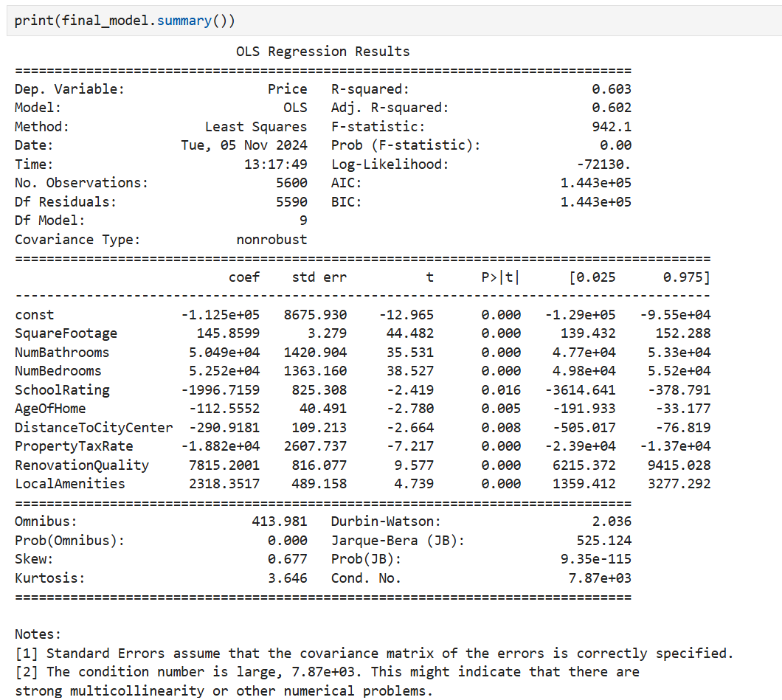

We'll go over several key metrics from this OLS Regression Result. The R-squared value in the model is 0.603, which means 60.3% of the variance in house prices can be explained by the independent variables in the model. The Adjusted R-squared value in the model is 0.602, and this value is slightly lower than the R-squared value. This means most independent variables in the model are useful for explaining the variation in house prices because the adjusted R-squared value did not get penalized as much.

The F-statistic value of the model is 942.1, which means the overall regression model is statistically significant and is much better at predicting house prices than a model with no predictors. The Prob (F-statistic) value is 0.00, which indicates that the overall regression model is highly significant and that its independent variables are important for predicting house prices.

For coefficient estimates, the variables with positive coefficients are SquareFootage, NumBathrooms, NumBedrooms, RenovationQuality, and LocalAmenities. These variables increase house prices when they increase. The variables with negative coefficients are SchoolRating, AgeOfHome, DistanceToCityCenter, and PropertyTaxRate. These variables decrease house prices when they increase. As for the p-values, the independent variables SquareFootage, NumBathrooms, NumBedrooms, SchoolRating, AgeOfHome, DistanceToCityCenter, PropertyTaxRate, RenovationQuality, and LocalAmenities all have p-values less than 0.05, which means they have a meaningful impact on the dependent variable Price and should be kept in the regression model.

**D3. Give the mean squared error (MSE) of the optimized model used on the training set**

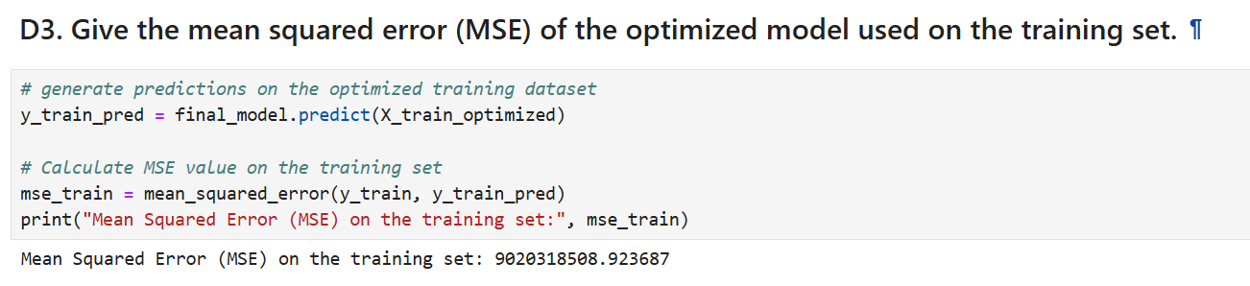

In this code, I used the optimized regression model final_model that we created from earlier to make predictions on the optimized training dataset X_train_optimized. The predictions will be stored inside the y_train_pred variable. Then, I used the mean_squared_error function to compute the MSE between the actual house prices in the training set and the predicted prices. The MSE value is 9020318508.92, which means that the squared difference between the predicted and actual house prices is 9020318508.92 on average. This large MSE value is expected because the house prices in the data are in the range of hundreds of thousands to millions, meaning this large MSE value is still reasonable.

**D4. Run the prediction on the test dataset using the optimized regression model to give the accuracy of the prediction model based on MSE**

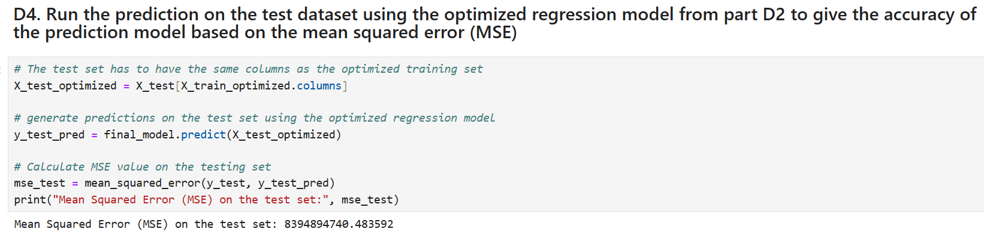

In this code, I made sure that the test set has the same columns as the optimized training set to ensure consistency. Then, I used the optimized regression model to make predictions on the test set. I used the mean_squared_error function to compute the MSE between the actual house prices in the test set and the predicted prices. The MSE value is 8394894740.48, which means the average squared difference between the predicted and actual house prices is 8394894740.48 on the test data. The MSE value on the test set is slightly smaller than the MSE value on the training set, which means the optimized regression model performs fairly consistently on both the training and test sets, it's just the model generalizes better on the test set. Also, having two similar MSE values indicates that the regression model is not heavily overfitting and can generalize well to new data.

**E1. List the packages or libraries you have chosen for Python and justify them**

The libraries that I have used to perform the analysis are Pandas, Matplotlib, Seaborn, Scikit-learn, and Statsmodels. I used the Pandas library for data manipulation and analysis. For example, I used the Pandas read_csv() function to read the housing.csv file and load its contents into a Pandas dataframe. I've also used its describe() function to provide descriptive statistics for each variable in the data. I used the Matplotlib library to customize both the univariate and bivariate visualizations for each variable. For example, I used the functions figure(), title(), x_label(), and y_label() from Matplotlib to customize the size, title, and labels for each visualization for presentability. As for the Seaborn library, I used its function histplot() to create histograms and see the distributions for all variables, and function regplot() to create scatterplots and see the correlations between the dependent variable Price and an independent variable. As for the Scikit-learn library, I used it because it contains useful tools for predictive data analysis. For example, the library has the train_test_split() function where it splits the dataset into training and testing sets. The library also contains linear models like linear regression, which is what we created from earlier to have a model that can predict house prices accurately with the help of independent variables from the data. The Scikit-learn library also have functions that evaluate model performance like mean_squared_error() and r2_score(). The mean_squared_error() function is very useful in our data analysis because we are able to see how the optimized regression model performs on both the training and testing sets. The r2_score() function is also useful because we get to see how effective the independent variables in our regression model are for explaining the variation in house prices. Lastly, I used the Statsmodels library for estimating statistical models. The functions that I specifically used from the library are OLS() and add_constant(). I used the Ordinary Least Squares function to estimate the relationship between each independent variable and Price, while I used the add_constant() function to add a constant term to both training and test sets.

**E2. Discuss the method used to optimize the model and justification for the approach**

The method that I used to optimize the regression model is the backward stepwise elimination technique. The backward stepwise elimination technique "starts with all predictors in the model, iteratively removes the least contributive predictors, and stops when you have a model where all predictors are statistically significant" (Kassambara, 2018, par. 3). This technique improved our regression model by iteratively eliminating independent variables that did not have statistically significant effects on Price. The key metric that the backward stepwise elimination technique uses to identify irrelevant variables is the p-value. The Ordinary Least Squares function is the one that provides the p-values for each variable, and it can be seen inside the backward_elim function we created from earlier. Independent variables with p-values that are greater than 0.05 are considered to be non-significant predictors and are removed from the model. In our case, the variables TransportAccess, EmploymentRate, and CrimeRate were non-significant predictors because they had p-values above 0.05, and hence they were removed. Only the statistically significant variables with p-values less than 0.05 were retained in the regression model.

The justification for using the backward stepwise elimination technique is to simplify the regression model by removing its irrelevant predictors, improving the model's interpretability. Also, the technique improves the performance of the regression model by reducing the risk of overfitting since only significant variables are kept, leading to better generalization on new data.

**E3. Discuss the verification of assumptions used to create the optimized model**

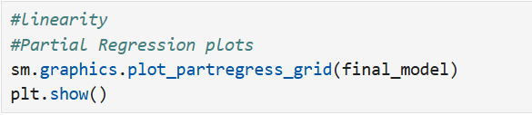

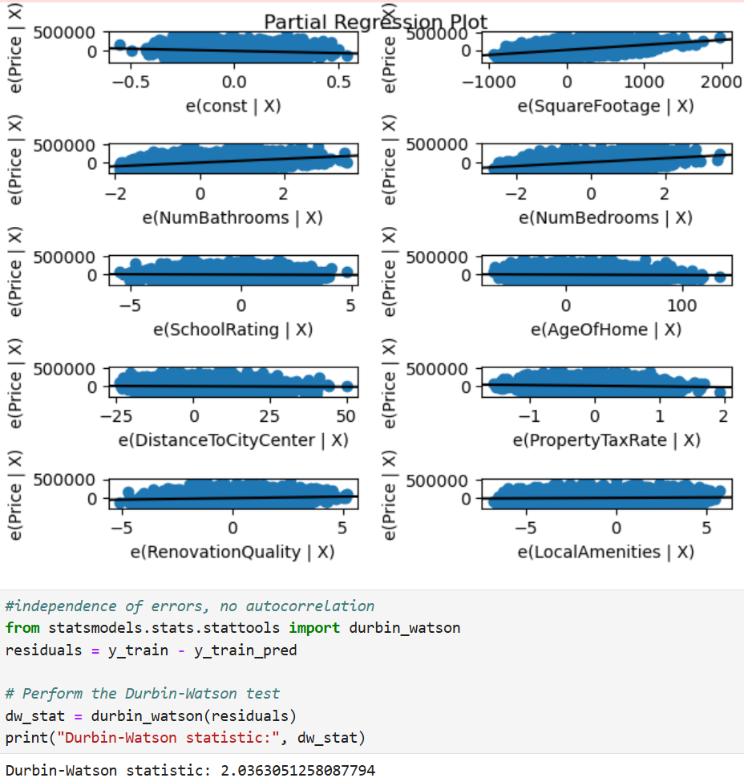

Since I was able to optimize our regression model by using the backward stepwise elimination technique, it is important to verify the assumptions of the Ordinary Least Squares (OLS) regression to ensure the accuracy and validity of the model. The two OLS assumptions that I verified are about linearity and independence of errors. Regarding linearity, the assumption is that there should be a linear relationship between the independent variables and the dependent variable. In our optimized regression model, the relationship between Price and the independent variables is indeed linear, as seen from the partial regression plots. Therefore, the linearity assumption is met. As for the independence of errors, the assumption is that the residuals should be independent of each other. This can be verified by using the Durbin-Watson test where it checks for autocorrelation in the residuals. After performing the Durbin-Watson test in our regression model, the value turns out to be 2.03. Since the DW value is close to 2, it means that there is no autocorrelation and the residuals in the model are independent. Therefore, the independence of errors assumption is also met.

**E4. Provide the regression equation and discuss the coefficient estimates**

Regression Equation: *Price* = *Intercept* + (*Coefficient of X1*) * *X1* + (*Coefficient of X2*) * *X2* + ... + (*Coefficient of Xn*) * *Xn*

Coefficients from our regression output: *Price = -112,500 + 145.85 * SquareFootage + 50,490 * NumBathrooms + 52,520 * NumBedrooms - 1996.71 * SchoolRating - 112.55 * AgeOfHome - 290.91 * DistanceToCityCenter - 18,820 * PropertyTaxRate + 7815.20 * RenovationQuality + 2318.35 * LocalAmenities*

The intercept value of -112,500 is the predicted value of Price when all independent variables are set to zero. It is the baseline level of price in the regression model. As for coefficients, we will go over the coefficients for each independent variable. The SquareFootage variable has a coefficient value of 145, which means for each additional square foot, the price of the house is expected to increase by about $145. The NumBathrooms variable has a coefficient value of 50,490, which means for each additional bathroom, the price of the house is expected to increase by about $50,490. The NumBedrooms variable has a coefficient value of 52,520, which means for each additional bedroom, the price of the house is expected to increase by about $52,520. The SchoolRating variable has a coefficient value of -1,996, which means for each unit increase in the school rating, the price of the house is expected to decrease by about $1,996. The AgeOfHome variable has a coefficient value of -112, which means for each additional year in the age of home, the price of the house is expected to decrease by about $112. The DistanceToCityCenter variable has a coefficient value of -290, which means for each unit increase in the distance from the city center, the price of the house is expected to decrease by about $290. The PropertyTaxRate variable has a coefficient value of -18,820, which means for each unit increase in the property tax rate, the price of the house is expected to decrease by about $18,820. The RenovationQuality variable has a coefficient value of 7815, which means for each unit increase in renovation quality, the price of the house is expected to increase by about $7815. The LocalAmenities variable has a coefficient value of 2318, which means for each unit increase of local amenities, the price of the house is expected to increase by about $2318.

To summarize, the variables with positive coefficients are SquareFootage, NumBathrooms, NumBedrooms, RenovationQuality, and LocalAmenities. These variables increase house prices when they increase. The variables with negative coefficients are SchoolRating, AgeOfHome, DistanceToCityCenter, and PropertyTaxRate. These variables decrease house prices when they increase.

**E5. Discuss the model metrics**

Regarding the model metrics R-squared and adjusted R-squared, both metrics can be seen from the OLS regression result from earlier. The R-squared value on the training set is 0.603, which means 60.3% of the variance in house prices can be explained by the independent variables in the model. An R-squared value of 0.603 indicates that the model captures a significant portion of the variability in house prices but not all of it. The Adjusted R-squared value on the training set is 0.602, and this value is slightly lower than the R-squared value. This means most independent variables in the model are useful for explaining the variation in house prices because the adjusted R-squared value did not get penalized as much. Also, since the adjusted R-squared value is very close to the R-squared value, it means that the model is not complex and doesn't suffer significantly from overfitting.

Regarding the Mean Squared Error (MSE) for both training and test sets, the MSE for the training set is 9020318508.92, while the MSE for the test set is 8394894740.48. The MSE value on the test set is slightly smaller than the MSE value on the training set, which indicates that the regression model performs consistently across both sets. Also, since both MSE values are similar, it suggests that the model is balanced and generalizes well to unseen data.

**E6. Discuss the results and implications of your prediction analysis**

The final regression model that we optimized using the backward stepwise elimination technique generalizes relatively well to unseen data without significant overfitting, as seen from its MSE values on both training and test sets. The independent variables in the model contribute meaningfully to explaining the variation in house prices, as shown from the model's r-squared and adjusted r-squared values. These variables are also statistically significant since they have p-values below 0.05. The variables with positive coefficients are SquareFootage, NumBathrooms, NumBedrooms, RenovationQuality, and LocalAmenities, and these variables increase house prices when they increase. The variables with negative coefficients are SchoolRating, AgeOfHome, DistanceToCityCenter and PropertyTaxRate, and these variables decrease house prices when they increase. Regarding the model's assumptions, we verified that there is indeed both linearity and independence of errors in the model by using partial regression plots and the Durbin-Watson test.

Overall, the optimized regression model provides a moderately good fit for predicting house prices based on its r-squared and adjusted r-squared values, similar MSE values for both training and test sets, and statistically significant coefficients. However, it is clear that the model still has room for improvement in terms of predictive accuracy.

**E7. Recommend a course of action for the real-world organizational situation based on your results and implications**

Based on the results and implications of our regression model, a course of action that organizations like real estate agencies or developers can perform is to focus on key determinants that have a positive relationship with Price and address the determinants that negatively affect Price. Regarding the key positive determinants of house prices, for example, organizations should make it a priority to increase square footage when designing properties or consider adding more bedrooms and bathrooms to properties to increase their price. Organizations should also invest in high-quality renovations and highlight local amenities in property listings, as these justify higher house prices. As for the negative determinants of house prices, organizations should prioritize investing in properties that are located near city centers because properties that are located far away from city centers typically have lower prices, as seen from the analysis. Also, knowing that older properties tend to have lower prices, investors should consider renovating older properties to increase their value.

**F. Panopto Video**

Here’s the link to my Panopto Presentation: <https://wgu.hosted.panopto.com/Panopto/Pages/Viewer.aspx?id=12afdfd0-6105-4ac4-8e7b-b21f015a0d14>

**References**

Kassambara, A. (2018, March 11). *Stepwise regression essentials in R*. STHDA. http://www.sthda.com/english/articles/37-model-selection-essentials-in-r/154-stepwise-regression-essentials-in-r/